**HO CHI MINH CITY PEOPLE'S COMMITTEE**

**SAIGON UNIVERSITY**

----- □ 🕮 □ -----

**ESSAY REPORT**

**SUBJECT: SOFTWARE TESTING**

**TOPIC: TESTING THE NON SON WEBSITE**

**Teacher instructions:** Dr. Do Nhu Tai

**Group:**

**Group members:** Huynh Ngoc Man – 3121411130

Nguyen Hoang Bao Huy – 3121411086

Nguyen Huu Duc – 3121411058

Nguyen Hoang Dang Khoa – 3121411104

# INDEX

INDEX 1

LIST OF IMAGES 4

LIST OF TABLES 7

PREFACE 8

ACKNOWLEDGMENTS 9

CHAPTER 1: TOPIC OVERVIEW 10

1.1 Project description 10

1.2 Business process 10

1.2.1 Customer purchasing process 10

1.2.2 Account management process 10

1.2.3 Product management process 11

1.2.4 Order management process 11

1.3 Association entity model 12

CHAPTER 2: REQUIREMENT SPECIFICATION 13

2.1 Overview 13

2.1.1 Overview diagram of the system's functions 13

2.2 Association Entity Schema 14

2.2.1 Participating actors 15

2.2.2 Main functions 15

2.2.3 Main entities 16

2.2.4 Decomposition diagram of system functions 16

2.3 Require each function 19

2.3.1 Product catalog 19

2.3.2 Product management 22

2.3.3 Shopping cart 25

2.3.4 List of accounts 27

2.3.5 Payment processing 29

2.3.6 Order 31

2.3.7 Access control 32

2.4 Non-functional requirements 34

2.4.1 Compatibility 34

2.4.2 Interface and experience 34

CHAPTER 3: TEST PLAN 36

3.1 Introduce 36

3.1.1 Purpose 36

3.1.2 Background 36

3.2 Features need to be tested 36

3.2.1 Functions need to be tested 36

3.2.2 Identify the project 38

3.3 Functional constraints 39

3.3.1 Product catalog, shopping cart and payment management 39

3.3.2 List of accounts 40

3.3.3 Manage products and product types 41

3.4 Functionality not tested 43

3.4.1 Order management 43

3.5 Testing strategy 43

CHAPTER 4: TEST DESIGN 45

4.1 Test Case Review Checklist 45

4.1.1 Purpose of Test Case Review Checklist 45

4.1.2 Test Case Review Process 45

4.2 Specification of functions 47

4.2.1 Product catalog 47

4.2.2 Shopping cart 50

4.2.3 Product management 53

4.2.4 Order 57

4.2.5 List of accounts 60

4.2.6 Payment processing 63

4.2.7 Access control 65

4.3 Test Design 68

4.3.1 Product catalog 68

4.3.2 Shopping cart 68

4.3.3 Payment processing 69

4.3.4 Access control 69

4.4 Test Design Workflow 69

4.4.1 Product catalog 70

4.4.2 Shopping cart 72

4.4.3 Payment processing 74

4.4.4 Access control 76

CHAPTER 5: TEST AND RESULTS 78

5.1 Manual testing 78

5.1.1 Bussiness Requirement Document (BRD) 78

5.1.2 Technical Requirement Document (TRD) 79

5.2 Test case design 80

5.2.1 Test cases according to the process 80

5.2.2 Test case cho unit test 82

5.3 Defect List 86

5.3.1 Error in the Purchasing process 87

5.3.2 Error in the Product Management process 87

5.3.3 Error in Account Management process 88

5.4 Test Results (Test Report) 89

5.4.1 Test results according to the process 90

5.4.2 Test results according to unit test 90

5.5 Bug Report 91

5.5.1 Bug number 1 91

5.5.2 Second bug 92

CHAPTER 6: CONCLUDE 93

6.1 Conclude 93

6.2 Development direction 93

REFERENCES 94

# LIST OF IMAGES

Figure 1.3.1: Entity-relationship diagram (ERD) of online sales management system 12

Figure 2.1.1.1: Diagram of system functions 13

Figure 2.2.1: Database relationship diagram of sales management system 14

Figure 2.2.4.1: Product catalog diagram 16

Figure 2.2.4.2: : Product management diagram 17

Figure 2.2.4.3: Shopping cart diagram 17

Figure 2.2.4.4: Order diagram 18

Figure 2.2.4.5: Account list diagram 18

Figure 2.2.4.6: Payment processing diagram 19

Figure 2.2.4.7: Access control diagram 19

Figure 2.3.1.1: Illustration of a product category page 20

Figure 2.3.1.1.1: Illustration of outstanding product categories 20

Figure 2.3.1.1.2 Illustration of low-cost product category 21

Figure 2.3.1.2. Illustration of the search function 21

Figure 2.3.1.3.: Illustration of combining price filtering and classification filtering 22

Figure 2.3.2.: Illustration of the management system in the product section 22

Figure 2.3.2.1.: Illustration when searching for products 23

Figure 2.3.2.2.: Further illustration of the product 23

Figure 2.3.2.3: Further illustration of the product 24

Figure 2.3.2.4.: illustration of hidden products 24

Figure 2.3.2.6.: Illustration of product type 24

Figure 2.3.2.7.: Further illustration of product types 25

Figure 2.3.3.1: Illustration of purchasing 25

Figure 2.3.3.2.1: Illustration of the Add to cart button 26

Figure 2.3.3.2.2: Illustration of the shopping cart icon 26

Figure 2.3.3.2.3: Illustration of shopping cart 27

Figure 2.3.4.1: Illustration of the account administration page 27

Figure 2.3.4.1.1: Illustration of additional accounts 28

Figure 2.3.4.2.1: Illustration of searching accounts by phone number 28

Figure 2.3.4.3.1: Illustration of editing user information 29

Figure 2.3.4.4.1: Illustration of a locked account 29

Figure 2.3.5.1.1: Payment illustration 30

Figure 2.3.5.1.2: Payment illustration 30

Figure 2.3.5.2.1: Payment illustration 31

Figure 2. 3.5.2.2: Illustration of successful payment 31

Figure 2.3.6.1: Illustration of the order management page 32

Figure 2.3.6.2: Illustration of order filtering 32

Figure 2.3.7.1: Illustration of order filtering 33

Figure 2.3.7.2: Illustration of the login page 33

Figure 2.3.7.3.1 : Illustration of logging out 34

Figure 4.3.1.1. Test Design of Product Catalog 68

Figure 4.3.2.1. Test Design of Shopping Cart 68

Figure 4.3.3.1. Test Design of Payment Processing 69

Figure 4.3.4.1. Test Design of Access Control 69

Figure 4.4.1.1. Activity Diagram of Product Category 70

Figure 4.4.1.2. Workflow of Product Catalog 71

Figure 4.4.2.1. Activity Diagram of Shopping Cart 72

Figure 4.4.2.2. Shopping Cart Workflow 73

Figure 4.4.3.1. Activity Diagram of Payment Processing 74

Figure 4.4.3.2. Payment Processing Workflow 75

Figure 4.4.4.1. Activity Diagram of Access Control 76

Figure 4.4.4.2. Workflow of Access Control 77

Figure 5.2.1.1. List of test cases according to process 81

Figure 5.2.1.2. Test case Login 81

Figure 5.2.1.3. Test case Register 81

Figure 5.2.1.4. Test case product category 81

Figure 5.2.1.5. Test case shopping cart 82

Figure 5.2.1.6. Test case of payment processing 82

Figure 5.2.2.1. List of test cases of unit test 82

Figure 5.2.2.2. Sequence diagram of Access Control 83

Figure 5.2.2.3. Test case for unit test of Access Control 83

Figure 5.2.2.4. Sequence diagram of Product Category 84

Figure 5.2.2.5. Test case for unit test of Product Category 84

Figure 5.2.2.6. Sequence diagram of the Shopping Cart 85

Figure 5.2.2.7. Test case for unit test of Shopping Cart 85

Figure 5.2.2.8. Sequence diagram of Account List 86

Figure 5.2.2.9. Test case for unit test of Account List 86

Figure 5.3.1.1. An illustrative error of the purchasing process 87

Below is an image demonstrating the above error: 87

Figure 5.3.1.2. Evidence of purchasing process errors 87

Figure 5.3.2.1. An illustrative failure of the Product Management process 87

Below is an image demonstrating the above error: 87

Figure 5.3.2.2. Evidence of Product Management process errors 88

Figure 5.3.3.1. An illustration of an Account Management process error 88

Below are images demonstrating the above error: 88

Figure 5.3.3.2. Evidence of errors in the Account Management process 89

Figure 5.3.3.3. Evidence of errors in the Account Management process (2) 89

Figure 5.4.1.1. Test report of 3 processes 90

Figure 5.4.2.1. Test reports of unit tests 90

# LIST OF TABLES

Table 2.1.1.2: Shows names and descriptions for each Use case 13

Table 2.2.2: Description of entities in the sales management system 15

Table 2.4.1.1: Table of requirements related to compatibility 34

Table 2.4.2.1: Table of requirements related to interface and experience 35

Table 3.1.5.1: List of testing documents 39

Table 3.4.1: Test strategy table 44

Table 4.1.1: Test Case Review Checklist 46

Table 4.2.1.1: Focus Use Case of product category 47

Table 4.2.2.1: Focus Use Case of the shopping cart 50

Table 4.2.3.1: Focus Use Case of product management 53

Table 4.2.4.1: Focus Use Case of the order 57

Table 4.2.6.1: Focus Use Case of payment processing 63

Table 4.2.7.1: Focus Use Case of access control 65

Bảng 5.1.1.1: Bussiness requirement document 78

Bảng 5.1.2.1: Technical requirement document 79

# PREFACE

In the current era of rapidly developing information technology, applications and website systems play an important role in all fields, especially in e-commerce. Building a quality website not only requires eye-catching interface design but also ensures stable, safe and effective performance. Therefore, website testing is an extremely important job to ensure the quality and effectiveness of the system.

The project "NON SON WEBSITE TESTING" was carried out to learn and apply testing methods to check the quality of a specific e-commerce website. Non Son website is an online shopping platform specializing in providing hats and fashion accessories, with the goal of providing an easy and convenient shopping experience for customers. However, to meet high requirements for quality and features, the website needs to go through detailed testing steps to detect and fix errors.

In this project, we will perform functional testing and interface testing of the Non Son website, thereby providing solutions to improve and optimize the system's performance. In addition, we will also apply automated and manual testing techniques to evaluate the accuracy and effectiveness of the features.

This project was carried out with dedicated guidance and advice from Dr. Do Nhu Tai, who provided valuable knowledge and timely encouragement to help us complete the work. We are also very grateful to the teachers at school for imparting to us the basic knowledge of software testing, helping us apply it in practice.

With determination and effort, we hope that this project will make a small contribution to improving the quality and efficiency of e-commerce websites, thereby helping businesses develop more sustainably in the future. today's competitive environment.

# ACKNOWLEDGMENTS

To complete the essay "TESTING THE NON SON WEBSITE", we would like to express our deep gratitude to the teachers at the school for their dedicated teaching and imparting to us the fundamental lessons, the necessary knowledge to complete this essay.

In particular, we would like to express our sincere thanks to Dr. Do Nhu Tai, instructor, who taught, shared and encouraged us. Those lessons are really useful for us in completing our essays.

With limited experience and expertise, the process of completing our essays still faces many difficulties and errors are inevitable. Therefore, we look forward to receiving many suggestions and feedback from you to improve our essays.

Once again, we would like to sincerely thank our teachers!

# TOPIC OVERVIEW

## Project description

As a customer, they want an easy and convenient shopping experience. The system needs to provide the ability to search and filter products by name, type and price, helping customers quickly find the right product. After selecting a product, customers want to see details such as name, price, image and add to cart. They also need the ability to edit their cart, change quantities, or remove unnecessary products.

When checking out, customers want a fast process, support for multiple payment methods, and receive notifications about order status. The system also needs to allow customers to easily manage their accounts, update personal information and track their orders.

In short, customers need an e-commerce website that is easy to use, from product search to payment and order tracking.

## Business process

### Customer purchasing process

The customer's purchasing process begins when they visit the product category page of the website. Here, customers can search for products by name, type or price. By using filters and search features, customers can easily narrow down product lists to find items that suit their needs. After finding the desired product, customers can click on the product to view details, including the product name, description, price, and images. If satisfied, customers can add products to the cart with just one click.

Once customers have added products to the cart, they can review cart information, including product names, images, prices of each item and total value of the order. If necessary, customers can change product quantities or delete items they no longer want to buy. Once the shopping cart is ready, the customer can proceed to checkout. To pay, customers need to provide delivery information and payment method. The system will validate this information, and if all is valid, the payment process will be completed. If there is a problem with the information, the system will notify an error and cancel the transaction.

Finally, when the payment process is complete, the system updates the order's payment status and sends a confirmation message to the customer, notifying them that their order has been successfully processed.

### Account management process

The account management process begins when the administrator logs in to the administration system. One of the important functions that administrators need to perform is adding new user accounts. The administrator will fill in basic user information such as name, phone number, address and email into the system. Once the information has been fully entered, the administrator presses the "Save" button to create a new user account.

In addition to adding accounts, administrators can also edit account information. Administrators search for accounts that need editing by criteria such as name, phone number or email. Once the account is found, the administrator can change information such as address, phone number or update other data related to the user account. After editing is complete, the administrator saves the changes.

Besides, administrators can also search and manage the status of user accounts. If necessary, the administrator can lock a certain user's account, making it impossible for them to log in to the system. Administrators can also reopen locked accounts when necessary, helping users continue to use the service.

### Product management process

The product management process begins when an administrator logs in to the product administration system. To add new products to the system, administrators will use the "Add product" function. After filling in all product information such as product code, product name, description, price, image and product type, the administrator clicks "Save" for the new product to be added to the system database. system.

When needing to edit product information, administrators can search for products by name or other criteria. After selecting the product to edit, admins can change information such as price, description, or product image. When editing is complete, the administrator will save the changes to update product information in the system.

If there is a product that is no longer relevant or does not want to be displayed anymore, the administrator can remove the product from the catalog. The administrator will search for the product that needs to be deleted, then confirm and delete that product from the system. This helps maintain accuracy and updates in the website's product catalog.

In addition, admins can also manage the status of each product, such as displaying products and hiding products from the website. When a product is out of stock or no longer wanted to be displayed on the website, the administrator will change the product's status so that it no longer appears in the product list.

### Order management process

The order management process helps administrators track and process customer orders. Admins can check the details of each order, including the order's current status, customer information, payment method, and expected delivery date. If needed, admins can filter orders by criteria such as status, creation date, or shipping address for easy management. After checking the order, the admin can update the order status, for example moving from "processing" to "delivered" or "cancelled". The system will process the payment transaction and notify the payment results to the customer. Finally, admins can also notify customers of order results, including order confirmation information and expected delivery time. This process helps administrators ensure that all orders are processed accurately and promptly, enhancing the customer experience.

## Association entity model

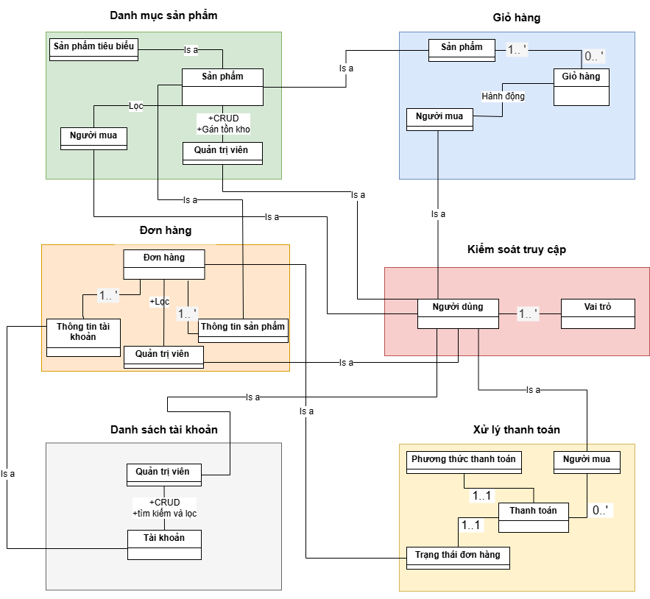`

*Figure 1.3.1: Entity-relationship diagram (ERD) of online sales management system*

*Figure 1.3.1* The above shows the relationship between main components in the system such as product categories, shopping carts, orders, user accounts and payment processes. In it, buyers can search, filter products, add or remove products in the cart and make payments, while administrators can manage products, orders, accounts and access control. The main functions of the system include CRUD data filtering, payment processing and user authorization. This diagram helps clearly identify entities and relationships between them, serving as an important basis for effectively building and developing the system.**. [1]**

# REQUIREMENT SPECIFICATION

## Overview

### Overview diagram of the system's functions

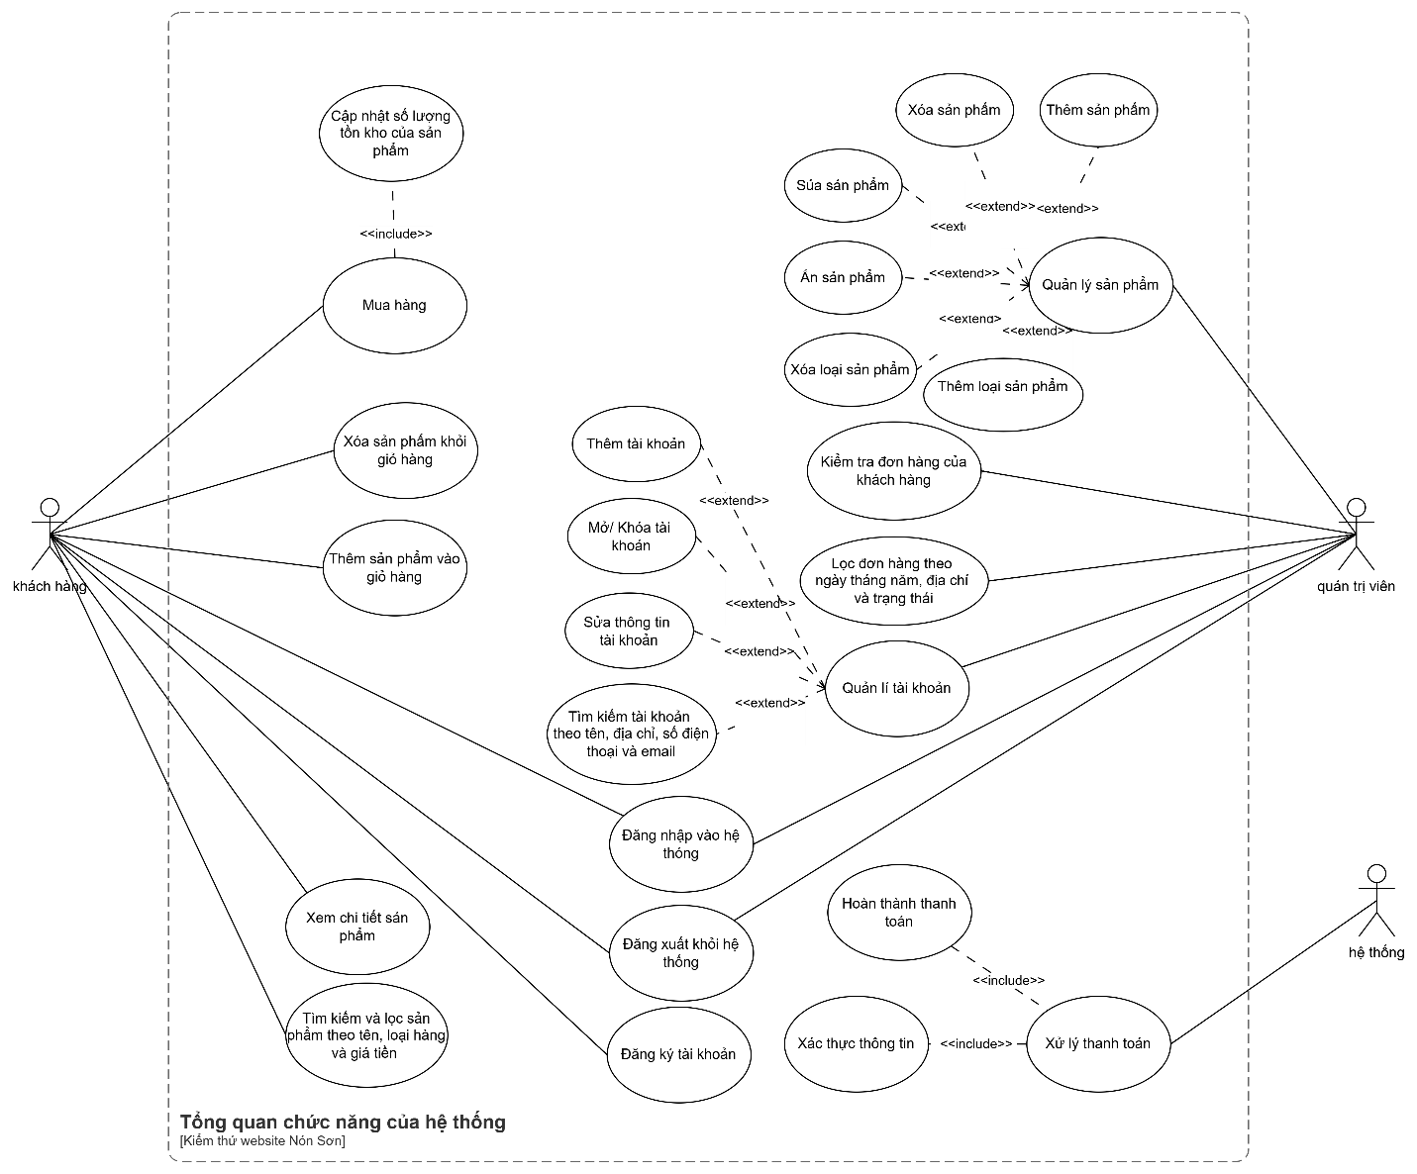

*Figure 2.1.1.1: Diagram of system functions*

From figure 2.1.1.1 we have the following table:

*Table 2.1.1.2: Shows names and descriptions for each Use case*

|  |  |  |
| --- | --- | --- |
| Use case | Name | Describe |
| UC1 | Product catalog | Describe the process by which customers interact with the product catalog. |
| UC2 | Shopping cart | Describe the process by which customers interact with the shopping cart. |
| UC3 | Product management | Describe the process of how Administrators interact (Add, delete, edit, hide) products in the system. |
| UC4 | Order | Describe the process for Administrators to view and filter orders by day, month, year, address and status |
| UC5 | Account management | Describe the process of Administrator interacting (Add, edit, lock, search) with the list of accounts in the system. |
| UC6 | Payment processing | Describes the process by which the system processes payments. |
| UC7 | Access control | Describes the customer registering and logging in, and the administrator logging in to the system. |

## Association Entity Schema

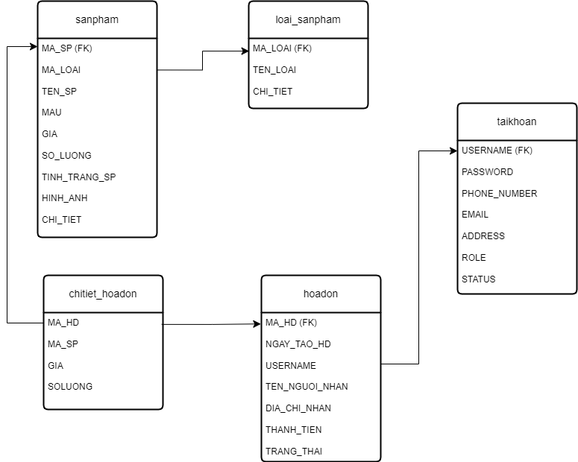

*Figure 2.2.1: Database relationship diagram of sales management system*

From figure 2.2.1 we have the following table:

*Table 2.2.2: Description of entities in the sales management system*

|  |  |  |
| --- | --- | --- |
| # | **Entity** | **Describe** |
| 1 | sanpham | Store detailed information about products in the system. |
| 2 | loaisan_pham | Manage information about product types in the system. |
| 3 | hoadon | Store customer order information. |
| 4 | chitiet_hoadon | Store details of products in each invoice, including quantity and price of each product. |
| 5 | taikhoan | Stores user information, including customers and system administrators. |

### Participating actors

* Customer: is the agent of the website, can make purchases, view products, search and filter products.
* Administrator: is the person who manages the website system from things such as accounts, invoices, products, ...
* System: processes payments, notifies customers such as error messages.

### Main functions

* Login/Register: Agents can create a new account or log in to an existing account to use system features.
* Purchase: The agent can make a payment to complete the purchase of the product.
* Remove products from the shopping cart: The agent can remove unwanted products from the shopping cart.
* Add product to cart: Agent adds desired product to cart to prepare for purchase.
* View product details: Agents can view detailed information of a specific product.
* Search and filter products: The agent searches for products using keywords and filters by category or price.
* Add product: Administrator adds new product to the system with information such as code, name, price, ...
* Delete product: Administrator deletes product from the system.
* Edit product: Admin can edit product information.
* Hide products: Admins can temporarily hide products from the display list.
* Add product type: Administrator adds new product type to the system with information such as code, product type name, ...
* Delete product categories: Admin deletes unnecessary product categories.
* Check orders: Administrators check information about shoppers' orders.
* Filter orders: Admin filters orders by status, creation date, or address.
* Add account: Admin adds a new account (for example, an administrator account).
* Unlock/Lock account: Administrator can unlock or temporarily lock agent account.
* Edit account: Administrator edits account information.
* Account search: Administrator searches for agent accounts by id code, name,...
* Payment processing: The system processes payment transactions of the actor.

### Main entities

* Account: Information about agents in the system (Account can belong to the customer or administrator) including name, address, phone number, ...
* Product type: Manage information about product types in the system.
* Products: Stores detailed information about products in the system. These are the items purchased by customers.
* Invoice: Stores information about purchase transactions, each invoice corresponds to one purchase.
* Invoice details: Store detailed information about the products in each invoice, showing purchased products and quantities. **[2]**

### Decomposition diagram of system functions

#### Product catalog

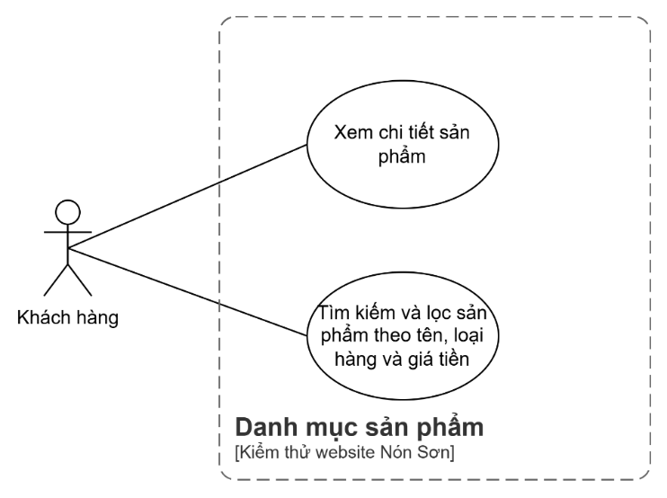

*Figure 2.2.4.1: Product catalog diagram*

#### Product management

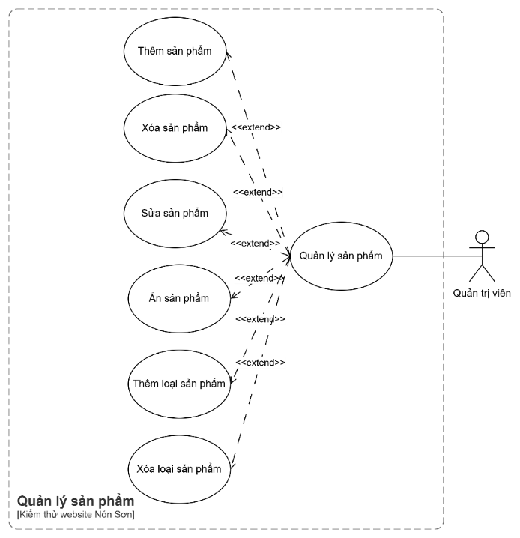

*Figure 2.2.4.2: : Product management diagram*

#### Shopping cart

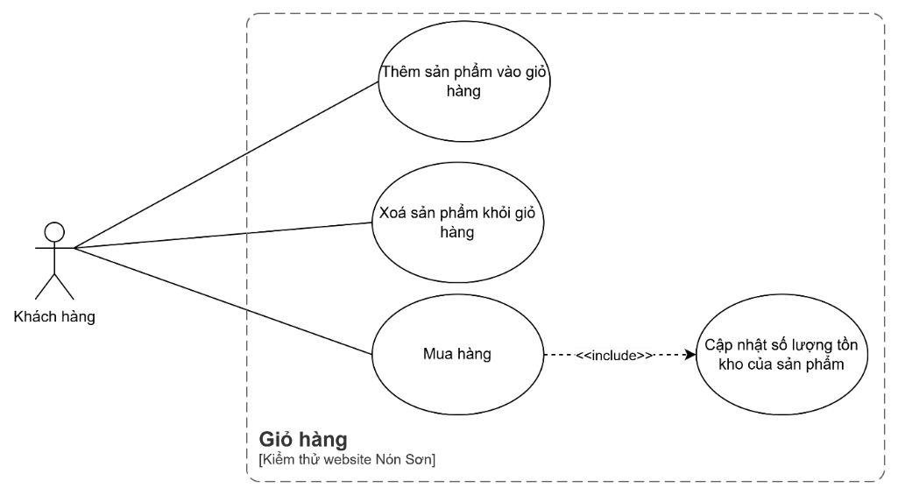

*Figure 2.2.4.3: Shopping cart diagram*

#### Order.

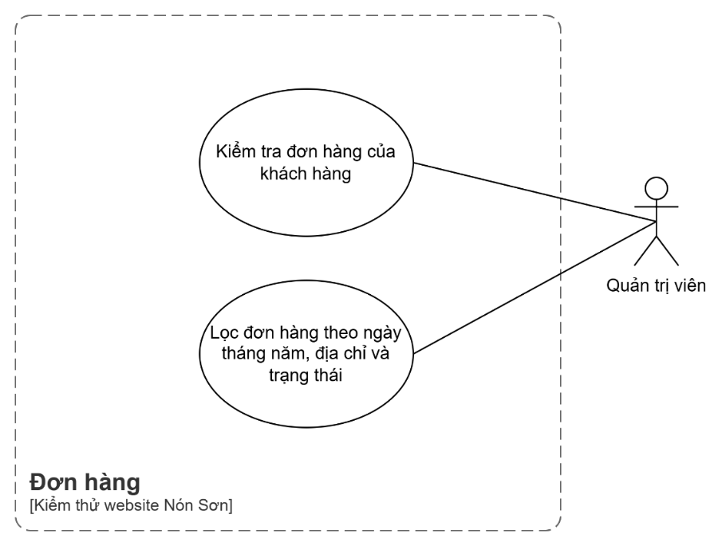

*Figure 2.2.4.4: Order diagram*

#### List of accounts

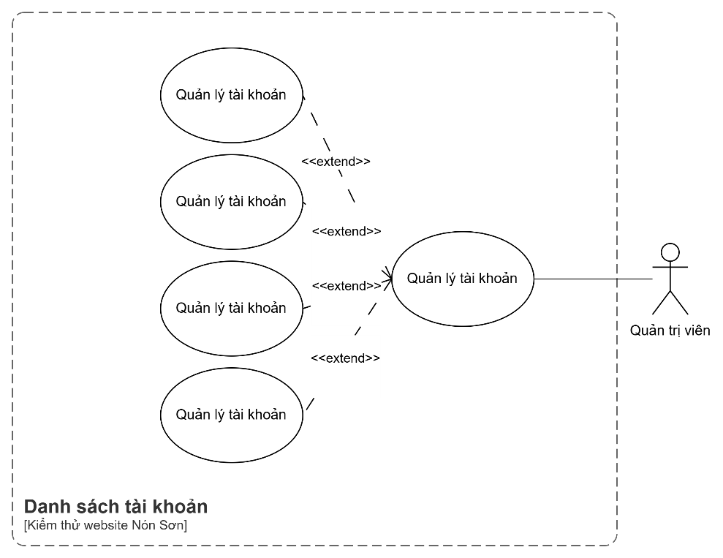

*Figure 2.2.4.5: Account list diagram*

#### Payment processing

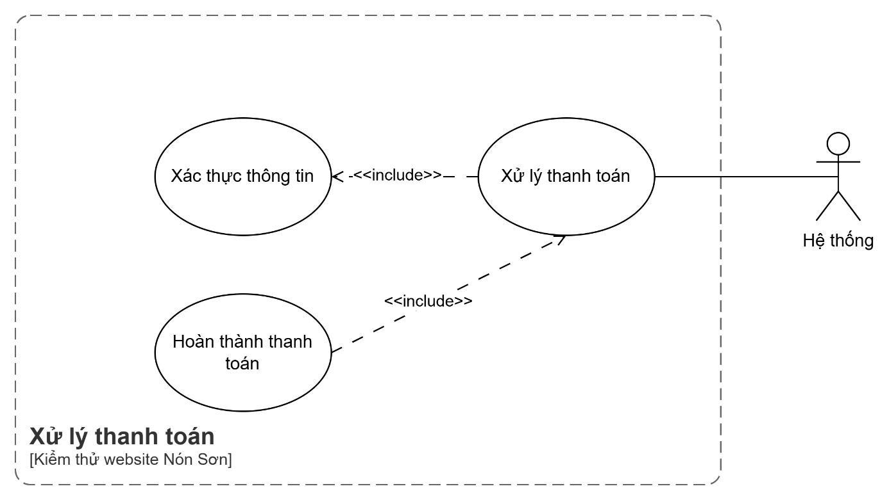

*Figure 2.2.4.6: Payment processing diagram*

#### Access control

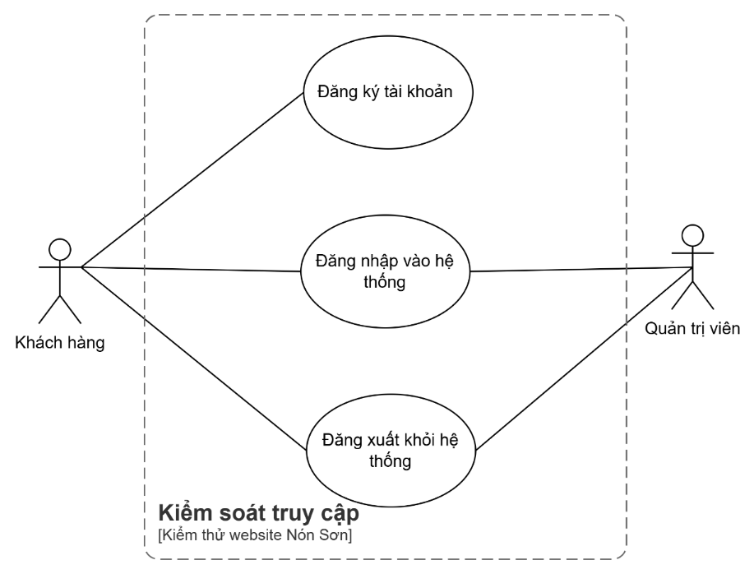

*Figure 2.2.4.7: Access control diagram*

## Require each function

### Product catalog

When a user logs in to their account or accesses the website, the product list screen will display all the products that are in stock. This page displays two sections: "Cheap products" and "Products". Featured” will be divided into 8 products per section. At the same time, display categories to choose from such as “All”, “Cheap products”, “Featured products”, “Full face hats”, “1 / 2 head hats”, “3 / 4 head hats ” or users can choose explore to view each category. There is also a search box for users to search for products.

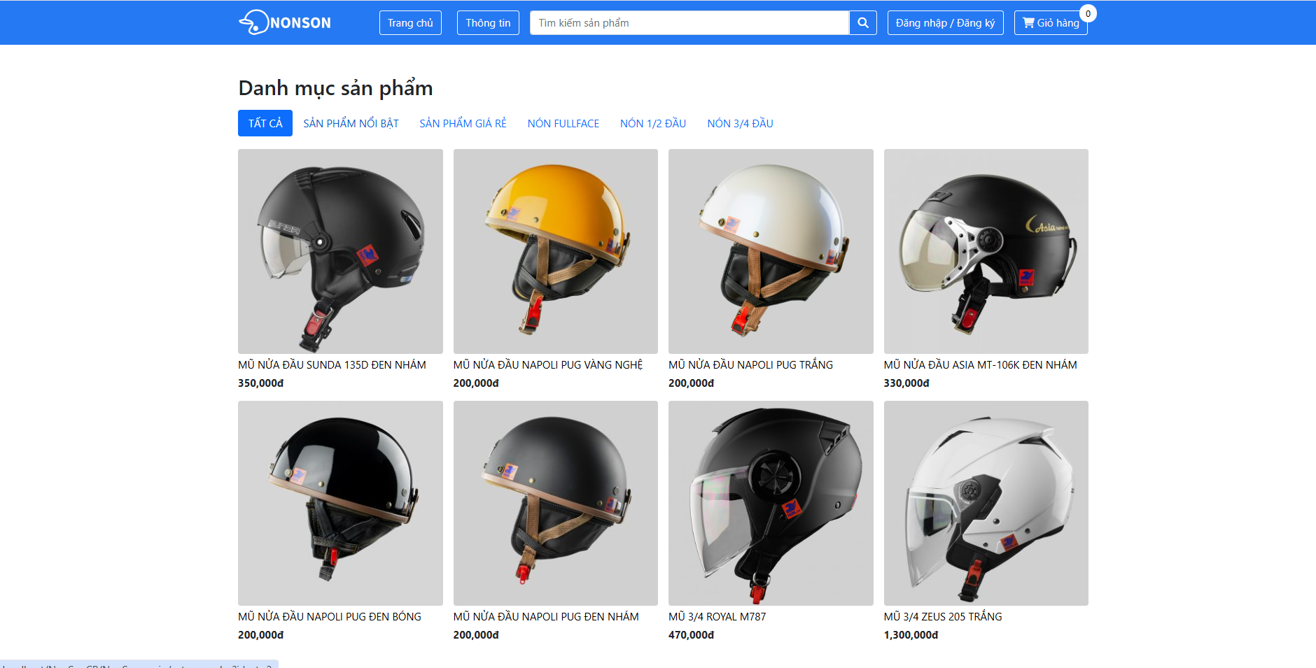

*Figure 2.3.1.1: Illustration of the product category page*

#### Product categories

When the user chooses to explore, the system will take the user to the featured product page, and there are additional categories for users to choose to view. Each page is divided into 8 products.

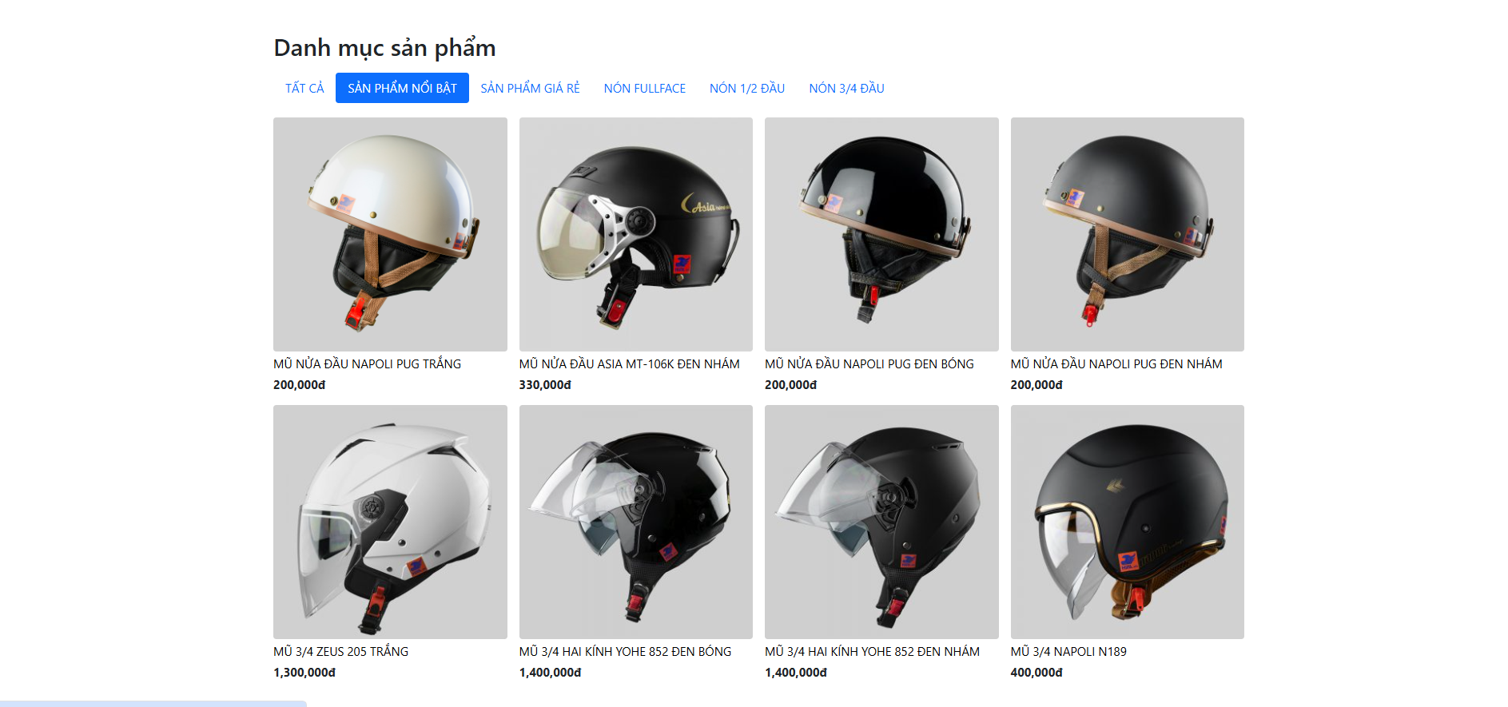

*Figure 2.3.1.1.1: Illustration of outstanding product categories*

Similarly, when selecting other categories, it will also be taken to the above page but in a different category. For example, selecting "Cheap products", the user is taken to the cheap product page.

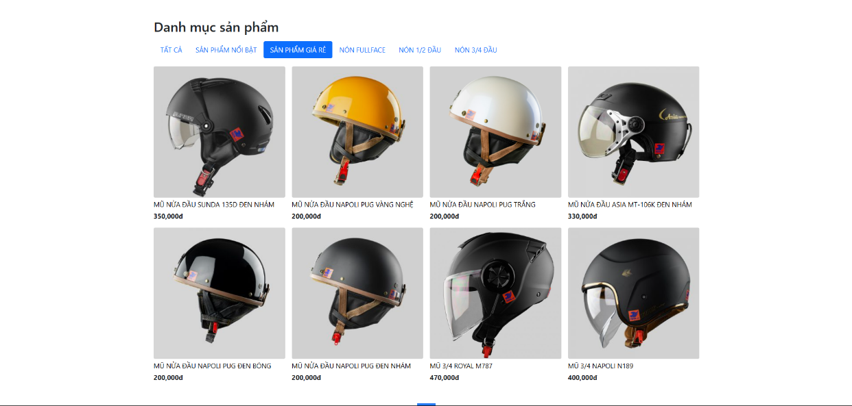

*Figure 2.3.1.1.2 Illustration of low-cost product category*

#### Search for products at customers

When the user chooses to search for a product, the system displays suitable results.

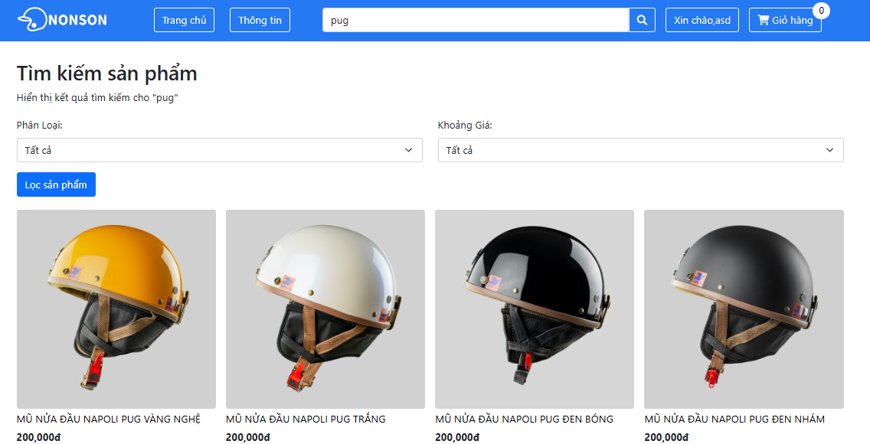

*Figure 2.3.1.2. Illustration of the search function*

#### Filter products at customers

Here, we have additional filtering functions including filtering by classification and filtering by price range.

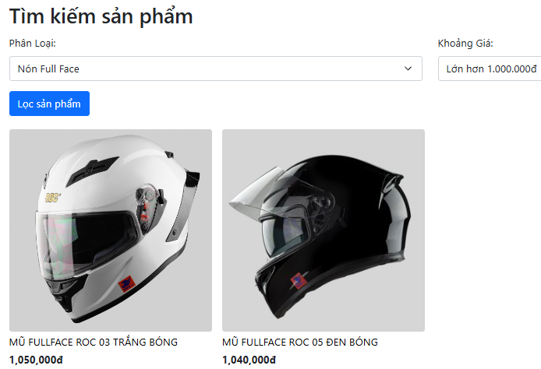

*Figure 2.3.1.3.: Illustration of combining price filtering and classification filtering*

### Product management

When a user logs in to the administrator account, the system takes the user to the administration system.

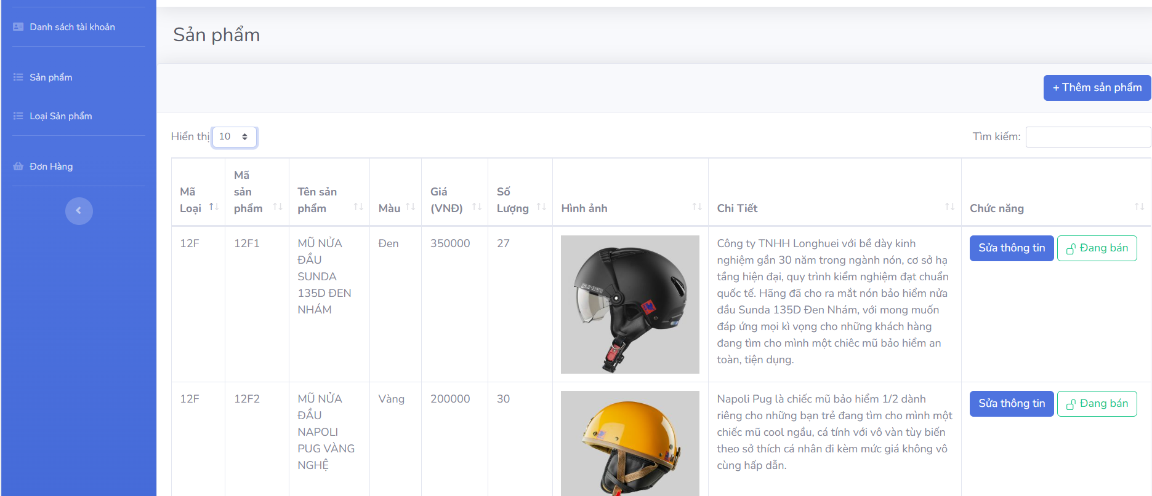

*Figure 2.3.2.: Illustration of the management system in the product section*

Here, the administrator functions are displayed. In this section, the things that need to be manipulated are "Product" and "Product type". At the product, display the information of the product being posted along with the functions. Here users can do operations such as choosing the number of displayed products they can view per page including 10, 25, 50, 100. In addition, users also have functions such as editing information, hiding and Search and add products.

#### Search management products

When the administrator selects search and enters information in the search box, the system will display the product to be searched.

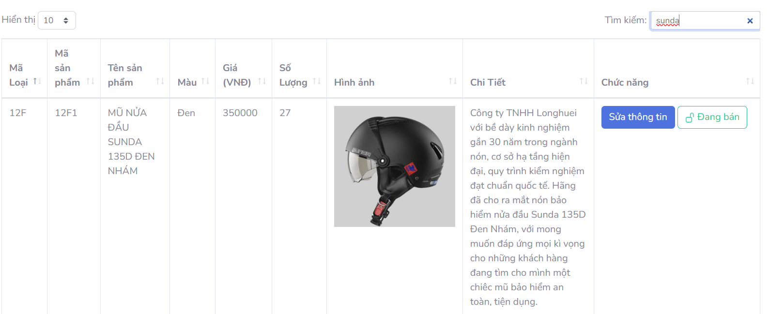

*Figure 2.3.2.1.: Illustration when searching for products*

#### Add products

When the administrator chooses to add a product, the system displays an information sheet for the user to fill out.

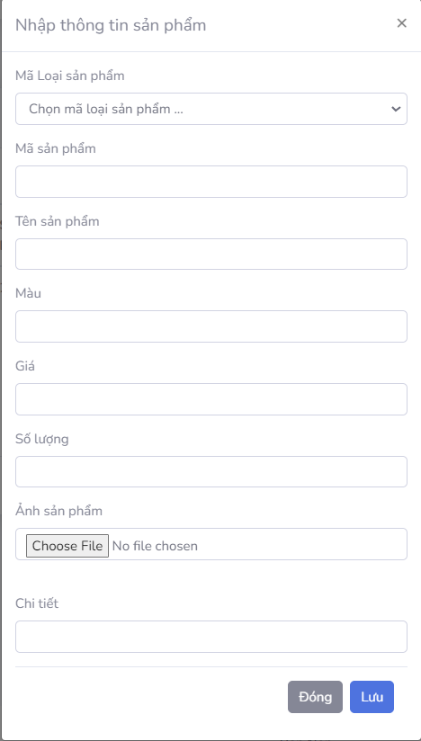

*Figure 2.3.2.2.: Further illustration of the product*

#### Edit product information

When the administrator chooses to edit product information, a table will appear similar to adding a product but with information already filled in.

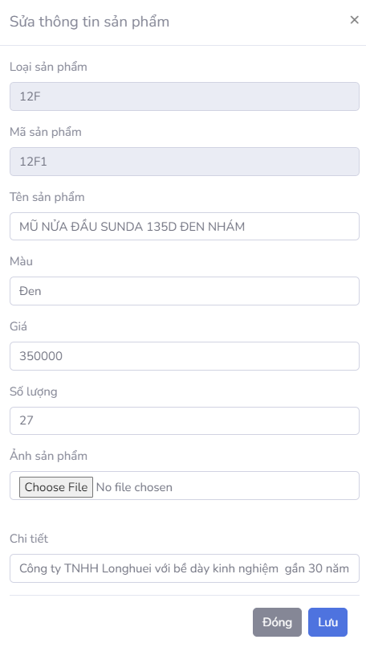

*Figure 2.3.2.3: Further illustration of the product*

#### Hide products

When the administrator chooses to hide a product (on sale), the product will be hidden outside the shop and the status is displayed as hidden.

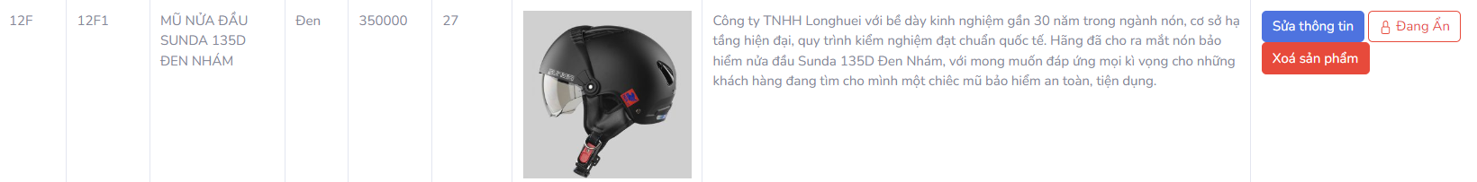

*Figure 2.3.2.4.: illustration of hidden products*

#### Delete product

When hidden, the admin can choose to delete the product, which will be deleted in the database.

#### Delete product type

When the admin chooses to delete a product type, it is required that the product type must not be linked to any product.

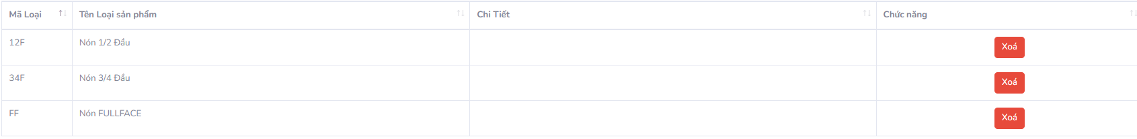

*Figure 2.3.2.6.: Illustration of product type*

#### Add product type

When the administrator selects an additional product type, the system displays an information panel for the user to fill in including product code, product name, and details.

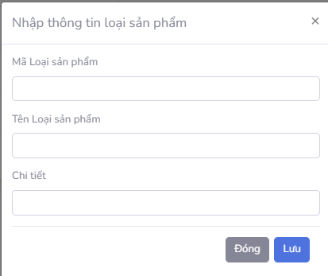

*Figure 2.3.2.7.: Further illustration of product types*

### Shopping cart

#### Purchase

When users click on a product to view product details as shown below.

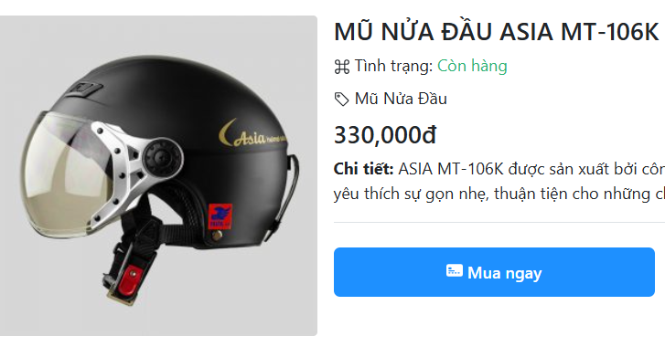

*Figure 2.3.3.1: Illustration of purchasing*

Continue pressing the "Buy now" button, a dialog box will appear to edit information and choose a payment method for the customer. If the customer has not logged in, a notification will appear and the customer will be redirected to the login interface.

Visit section 2.3.5 Payment Processing for more payment processing details.

#### Add to cart

When the user chooses to add to cart as shown below.

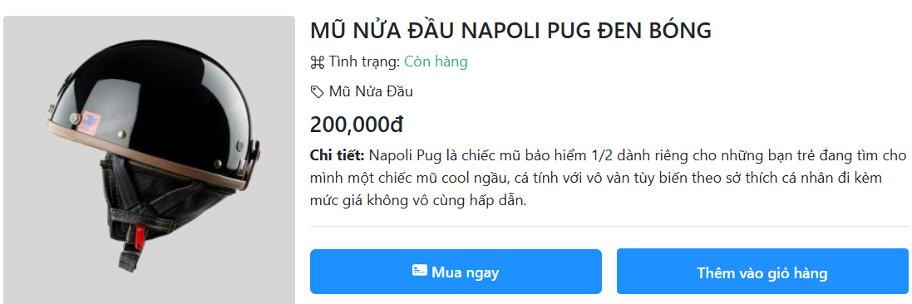

*Figure 2.3.3.2.1: Illustration of the Add to cart button*

When the user selects “Add to Cart”, the cart icon in the top right corner will automatically increase the quantity the user has added.



*Figure 2.3.3.2.2: Illustration of the shopping cart icon*

When we click on the Shopping Cart icon above, we will go to the shopping cart page and display the products in the shopping cart. If the user does not want to delete the product from the shopping cart, they will click on the X in the right corner of the product.

To pay, the user needs to log in. If not logged in yet, the system will notify and redirect the user to the login page.

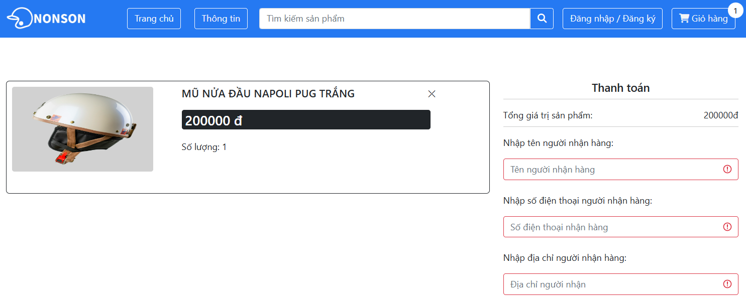

*Figure 2.3.3.2.3: Illustration of shopping cart*

Visit section 2.3.5 Payment Processing for more payment processing details.

### List of accounts

When administrators want to manage accounts, on the admin page, the system supports administrators with functions to manage accounts and supports viewing the number of accounts per page, the default is 10 accounts per page. page.

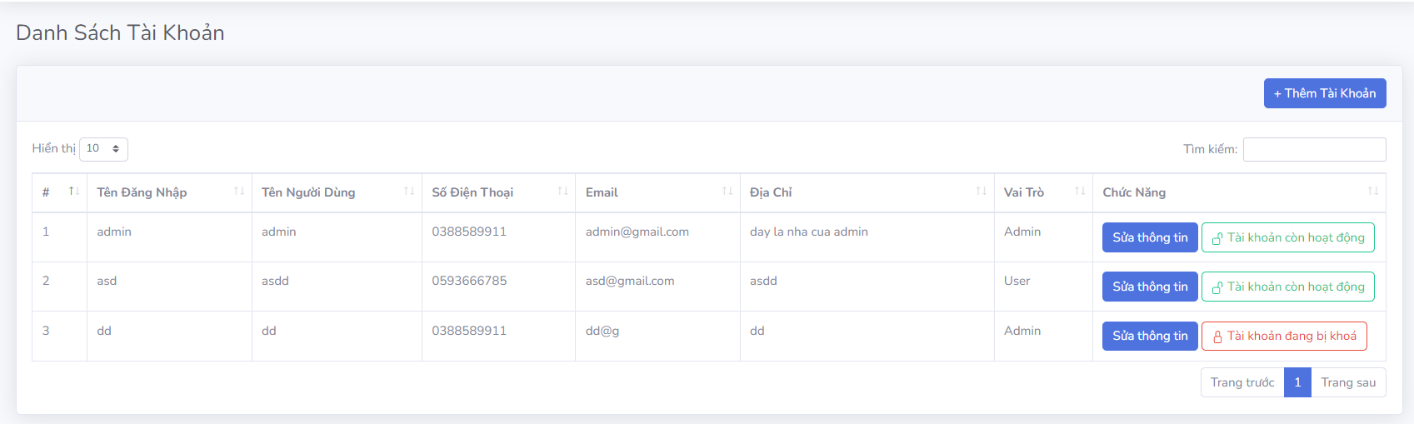

*Figure 2.3.4.1: Illustration of the account administration page*

#### Add account

When the administrator chooses to add an account, the system displays account information for the user to fill in.

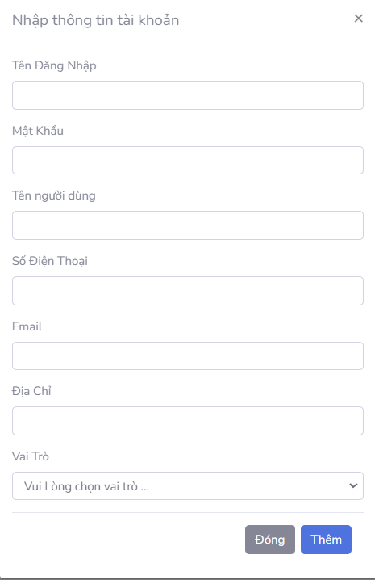

*Figure 2.3.4.1.1: Illustration of additional accounts*

#### Search accounts

When the Administrator chooses to search for a product by entering information in the search box (name, address, phone number and email), the system displays the account according to the search information.



*Figure 2.3.4.2.1: Illustration of searching accounts by phone number*

#### Edit account information

When the administrator chooses to edit information, the system displays an information panel similar to when adding an account.

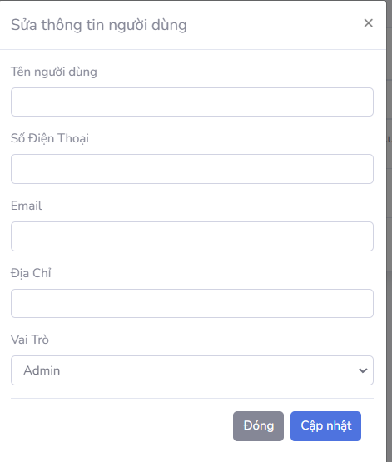

*Figure 2.3.4.3.1: Illustration of editing user information*

#### Open/Lock account

When an administrator chooses to lock an account, that account will not be able to log in to the shop.



*Figure 2.3.4.4.1: Illustration of a locked account*

### Payment processing

#### Pay at buy now

When choosing to buy immediately at the product, the system displays the payment information table as shown below:

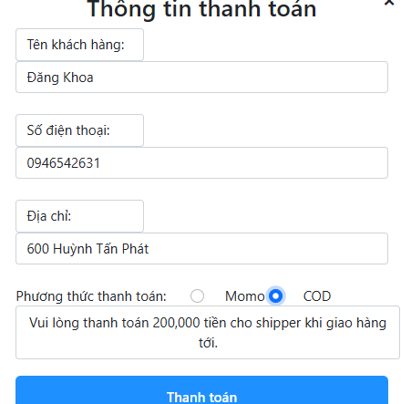

*Figure 2.3.5.1.1: Payment illustration*

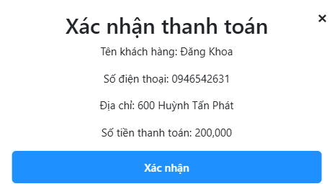

*Figure 2.3.5.1.2: Payment illustration*

When the user chooses to pay, checks the information and confirms, the system will confirm the information and complete the payment as shown in Figure 2.4.5.1.2.

#### Pay at cart

After successfully adding the products to buy, the user goes to the payment cart, where all information about the purchased products, total product value, name, phone number, address will be displayed. recipient and select payment method

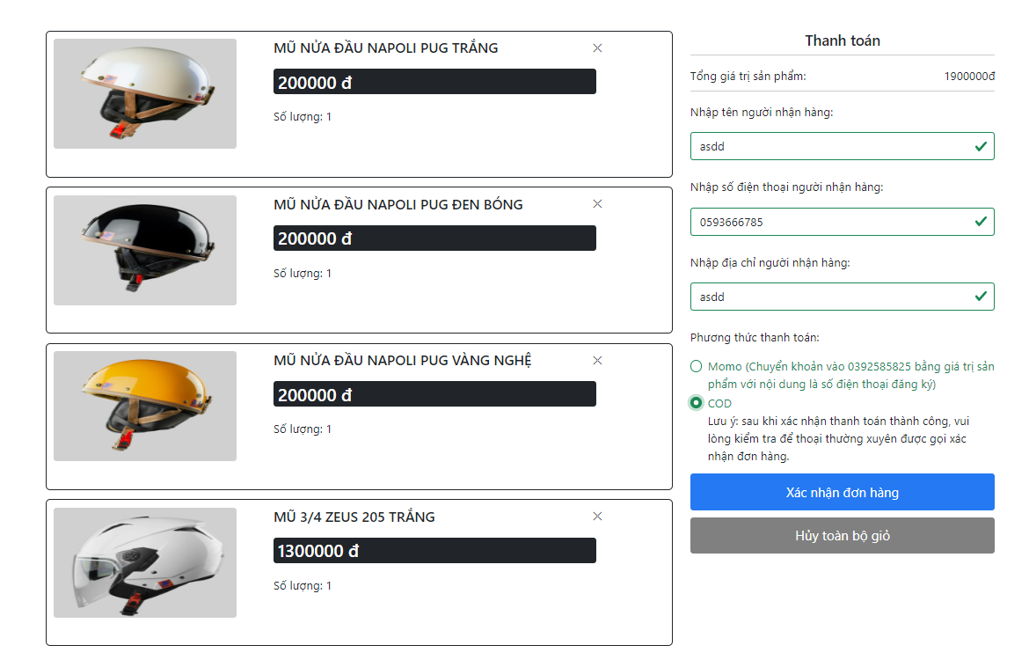

*Figure 2.3.5.2.1: Payment illustration*

When the user has checked and confirmed the payment, the system reports successful payment as shown in Figure 2.3.5.2.2

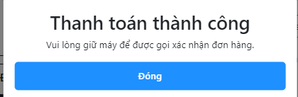

*Figure 2. 3.5.2.2: Illustration of successful payment*

### Order

The administrator selects the orders tab to view the orders placed. The system displays the order page including order information (Invoice code, order date, purchase account, orderer name, product code, address). index, price(VND), quantity, amount(VND), status) in addition there is a filter function

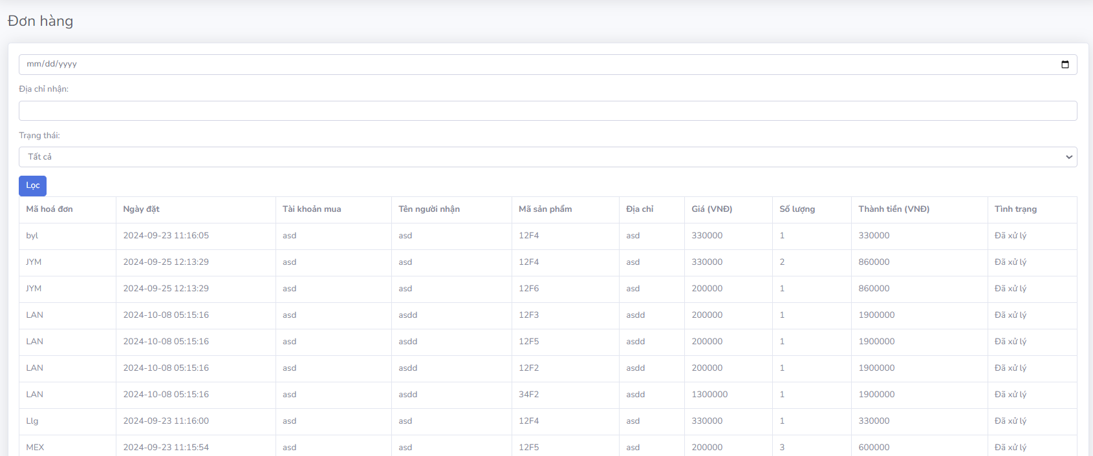

*Figure 2.3.6.1: Illustration of the order management page*

#### Filter orders

Users can filter orders by order date, delivery address, status or all three.

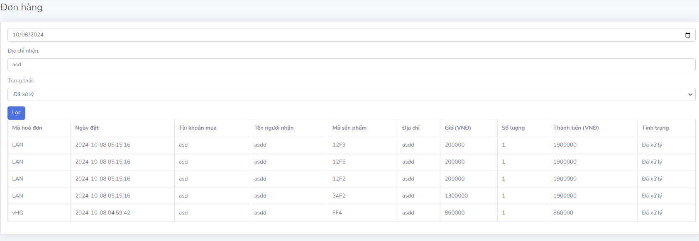

*Figure 2.3.6.2: Illustration of order filtering*

### Access control

#### Register an account

The user chooses to register an account at the login screen, the system takes the user to the registration page with information including login name, password, name, phone number, email and delivery address.

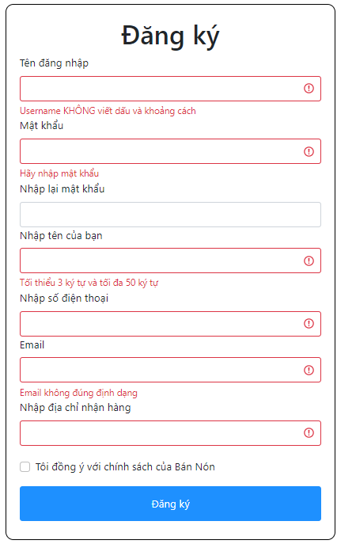

*Figure 2.3.7.1: Illustration of order filtering*

When the user enters all the information and chooses to register, the system confirms and creates the information in the database.

#### Log in

After registering, return to the login screen, where the user logs in by entering username and password, then the system authenticates. If the user logs in with a customer account, they will go to the shop's home page, if the user logs in with an administrator account, they will go to the admin page.

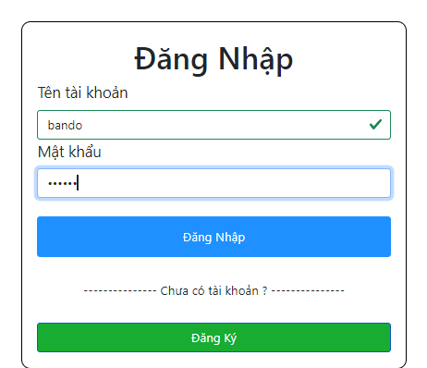

*Figure 2.3.7.2: Illustration of the login page*

#### Sign out

When the user chooses to log out, the system will automatically return to the login page.

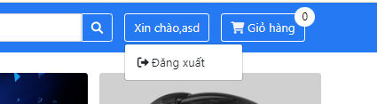

*Figure 2.3.7.3.1 : Illustration of logging out*

## Non-functional requirements

### Compatibility

*Table 2.4.1.1: Table of requirements related to compatibility*

|  |  |
| --- | --- |
| **Compatibility related requirements** | |
| **No.** | Request |
| 1. | * The system must support popular browsers such as Google Chrome, Firefox, Safari and Microsoft Edge. |

### Interface and experience

|  |  |
| --- | --- |
| **Requirements related to interface and experience** | |
| **No.** | **Request** |
| 1. | All pages on the website must have a consistent look and feel to provide a seamless user experience:   * Colors, fonts, font sizes, and design elements must be consistent across the entire website. * Logos and branding elements must appear uniformly across all pages. |
| 2. | The website's interface must be user-friendly, easy to navigate and find information:   * The navigation menu should be clear and easy to use, users can access main pages with just 1-2 clicks. * All icons and buttons should have clearly descriptive labels so users immediately understand their function. * The product search feature should be prominent (for example, at the top of the page) and easy to use. |
| 3. | The website must have a relatively responsive design for a number of platforms such as Android, Ios, Windows,... |

*Table 2.4.2.1: Table of requirements related to interface and experience*

# TEST PLAN

## Introduce

### Purpose

The purpose of this document is to define a testing strategy and quality assurance method for an e-commerce website conical hats that specializes in providing helmets. This document will provide a detailed test plan for the application, ensuring that all functional and non-functional requirements are met before the website is launched.

### Background

Development System is an e-commerce website for selling helmets online. The goal of the system is to provide an easy and convenient platform for users to search, compare, and purchase helmets, while also supporting flexible payment and delivery methods.

The website was built with the goal of becoming an independent product in the online helmet sales market, with the ability to expand to integrate new features such as online customer support and promotions. , and integration with shipping partners.

## Features need to be tested

### Functions need to be tested

During system testing, the main functions that need to be tested include the following:

#### Product catalog

Filter products by category: Allows filtering and displaying products belonging to specific categories (for example, "FULLFACE HATS").

View list of featured products and cheap products: Display featured and cheap products on the homepage.

Search products by description: Allows users to search products by description (e.g. "cool, cool hat").

Check for products outside the category: Check the ability to search for products that are not in the category.

Display the number of products per page: Make sure the number of products displayed is correct (for example, 8 products per page).

Pagination in product categories: Allows pagination when there are many products.

Show cheap products in the discovery section: Display a list of cheap products in the discovery section.

Filter products by category and price: Allows you to filter products by category and price range.

Search products by name: Allows searching products by name.

View product details: Display detailed product information when the user clicks on the product.

Continue shopping function: Allows users to return to the home page to continue shopping.

#### Shopping cart

Empty cart: Display a notification when the cart has no products.

Add product to cart: Allows adding products to cart and updating exact quantity.

Delete product from cart: Allows removing products from cart and updating cart quantity.

Change the number of products in the cart: Allows users to change the number of products in the cart.

Cancel entire cart: Allows users to delete all products in the cart.

Check product information in the shopping cart: Display detailed product information (name, price, quantity) in the shopping cart.

#### Payment processing

Enter valid payment information: Allows users to enter payment information and confirm orders when the information is valid.

Handling invalid payment information:

* Displays an error message if the recipient's name, phone number, address, or other payment information is invalid.
* Displays an error message if payment information is left blank.

Check payment success: Display "Payment success" message when the information is valid and the order is confirmed.

Processing payments when information is missing or incorrect: Display an error message if there is incorrect or missing information during the payment process.

#### Add account

Allows admins to enter information such as: Login name, password, user name, address, phone number and role

#### Search accounts

* Find accounts by username.
* Find accounts by username.
* Find accounts by email.
* Find accounts by address.
* Find accounts by role.
* Find accounts by account status.

#### Edit account information

Allows admins to edit account information such as: Username, email, address, phone number and role

#### Add products

Admin can add new products to the system by entering detailed information such as product name, description, price, image, and product type. After clicking "Add", the new product will be displayed in the list and the system will notify "Product added successfully".

#### Delete product

Admin can delete products from the system when no longer needed. After selecting the product to delete and confirming, the product will be removed from the list and the system will notify "Product has been successfully deleted".

#### Repair products

Admins can edit existing product information, such as changing prices, updating descriptions, or changing images. After editing and saving, the system will display the message "Product edited successfully".

#### Hide products

Admin can hide a product from the user interface without deleting the product from the system. When a product is hidden, customers won't be able to see it on the sales page. Products can be re-displayed when necessary.

#### Add product type

Admin can add new product types to the system to classify products appropriately. After entering the product type name and description, the system will display the product type in the list and notify "Product type added successfully".

#### Delete product type

Admin can delete a product type from the system when it is no longer in use. Once deletion is confirmed, the product type is removed from the list of product types in the system and can no longer be used for new products.

### Identify the project

*Table 3.1.5.1: List of testing documents*

|  |  |  |  |  |
| --- | --- | --- | --- | --- |
| Document | Created/available | Received/reviewed | Author/source | Note |
| Test case review checklist | Have | Have |  |  |
| Test case, test report | Have | Have |  |  |
| Unit test | Have | Have |  |  |
| Defect list | Have | Have |  |  |
| Test workflow | Have | Have |  |  |
| Sequence diagram | Have | Have |  |  |
| Test design | Have | Have |  |  |
| Test plan | Have | Have |  |  |

## Functional constraints

### Product catalog, shopping cart and payment management

#### Filter products by category

Displays the exact product list according to the selected category. Make sure that only products from that category are displayed.

#### Search products by description

Show products with matching descriptions. If there is no suitable product, the system should report no results.

#### Check for products outside the category

If the product does not belong to the existing category, the system should report no results.

#### Displays the number of products per page

Display the correct number of products per page (for example, 8 products/page). Other product quantities cannot be displayed.

#### See cheap products in the discovery section

Low-cost products should be displayed correctly when users select explore. It is not allowed to display products that are not in this group.

#### Filter products by category and price

Products must be accurately filtered according to the selected category and price level, ensuring there are no inappropriate products displayed.

#### Search products by name

The system must display products whose names match the search keywords. If there is no product, the system must report no results.

### List of accounts

#### Add account

When adding a new account, the system must display the message "Added successfully" and the account information just added to the account list.

When the admin leaves the input box blank, the system must notify "Please enter complete information!"

When entering a phone number, the system is only valid with numbers from Viettle, Vinaphone, Mobifone, Vietnammobile, Gmobile, Itelecom or other carriers authorized to use in Vietnam. If the format is incorrect, the system will notify you "The phone number entered is not in the correct format, please re-enter"

When entering email, the system is only valid if the email entered has the form abc@xyc.tail. When the entered email is invalid, the system must notify "The entered email is not in the correct format, please re-enter"

When entering a username or email, the system is valid if the username or email does not match the accounts that have been created. If it is the same, the system will notify "This username or email already exists. Please choose another username or email".

#### Find accounts

Find an account by login name: When the user enters the login name in the search box, the system must display the corresponding account. If there is no suitable account, the system should display "No results".

Search for an account by username: When a user searches for an account by username, the system will display the account with that username. If there is no suitable account, the system should display "No results".

Search accounts by email: The system will display accounts whose search emails match the request. If there is no suitable account, the system should display "No results"

Search accounts by address: When users enter an address, the system will display accounts with matching addresses. If there is no suitable account, the system should display "No results"

Search accounts by role: The system will display accounts with corresponding roles when the user enters the role in the search box. If there is no suitable account, the system should display "No results"

Search for accounts by status: When searching for accounts by status (e.g. locked accounts), if there is no matching account, the system should display "No results".

#### Edit account information

When the user edits account information, the information will be updated and the system should display the message "Update successful".

When editing email information, the system is only valid if the entered email has the form abc@xyc.đuôi. When the entered email is invalid, the system must notify "The entered email is not in the correct format, please re-enter". And if the email does not match an existing account, the system should display the message "Email is duplicate, please re-enter".

When editing phone number information, the system is only valid with numbers from Viettle, Vinaphone, Mobifone, Vietnammobile, Gmobile, Itelecom or other carriers authorized to use in Vietnam. If the format is incorrect, the system will notify you "The phone number entered is not in the correct format, please re-enter"

#### Lock account

When you lock your account, the account is locked and you can no longer log in.

Unable to lock the admin account performing the task. If locked, the system reports "This is an account currently logged in that cannot be locked"

### Manage products and product types

#### Add products

Check additional products successfully with valid information: When the entered information (product type code, product code, product name, color, price, quantity, details, image) are all valid, The system needs to display the message "Added Successfully" and the new product should be loaded and displayed with the entered parameters.

Product add check fails with invalid information: If the information entered is invalid (e.g. missing important data or in wrong format), the system should not add the product and not change the listing product book.

Additional product checking fails when information is missing: If some required information has not been entered (for example, missing product name, price), the system should display the error message "Please enter complete information". believe!" and no additional products are allowed.

#### Hide products

Successful product hide check: When a product for sale is selected and hidden, the product should change to "Hidden" status and not be visible on the official sale site. However, products can still be searched in the admin system.

Product unhide test is successful: When unhiding a product, the product must return to "For Sale" status and be visible on the official sale website. Note: only do this when the product has been previously hidden.

#### Delete product

Check for successful product deletion: When the user selects "Delete product" and confirms, the system must display the message "Delete successfully" and the product will no longer appear in the product list on the website.

#### Repair products

Check product information editing successfully with valid information: When product information is changed validly (for example: change price, quantity, description) and select "Save", the system must display message "Updating product information successfully!" and update new information on the product page.

Checking to correct product information fails when the modified information is invalid: If the modified information is invalid (e.g. invalid email, incorrect price format), the system should display the error message "Error Update product information!" and do not update product information.

Checking to fix product information fails when updated information is missing: If some important information is missing (e.g. missing product name, missing price), the system must display the message "Please fill in completely". enough information!" and does not allow updating product information.

#### Add Product Type

Required information:

The information fields that need to be entered include: product code, product name, details.

If information is missing, the system notifies: "Please enter complete information!".

Check for duplicates: The product type code must not overlap with an existing product type. If there is a match, the system displays the message: "This product type code already exists".

#### Delete Product Type

A product type is only deleted when there are no products related to that type code. If there are still related products, the system displays the message: "Please change product information with this code".

## Functionality not tested

### Order management

Function description: The order management function allows administrators to perform tasks related to managing orders including:

* Filter orders:
* Filter by booking date.
* Filter by receiving address.
* Filter by order status (e.g. Processed, Unprocessed).

View order details: Display order details such as invoice code, order date, purchase account, recipient name, product code, address, price, quantity, amount and order status.

Update order status: Change order status from “Unprocessed” to “Processed”.

Reasons for not testing:

* High level of stability: This function has been implemented and works stably in the previous version of the system.
* Low priority: Other functions such as adding products, account management, and payments are considered more important due to their direct impact on user experience and revenue.
* No new requirements arise: There are no requests for additional or functional changes from customers or project managers.

## Testing strategy

*Table 3.4.1: Test strategy table*

|  |  |
| --- | --- |
| Testing goal: | Ensure that the main functions of the website system operate correctly and stably, including functions such as product search, page navigation, data entry (especially user and product information), processing Transaction management (payment and ordering), and product information retrieval. Testing will focus on verifying whether functions meet operational requirements and are easy to use, to provide the best user experience. |
| Technique: | **Implement each use case:** Use cases will be identified and tested to ensure that all functionality performs as required.  **Use valid and invalid data:** Testing will be performed with valid and invalid data to verify that the system can handle both cases.  **Valid data:** Ensure that all input data fields such as product name, user information, credit card number, etc., when entered correctly, yield correct results.  **Invalid data:** Check for invalid input (for example, incorrect credit card information, invalid email address, or malformed phone number) to confirm the system displays an error message or warning report accurately. |
| Technology: | **GO:** Visual Studio Code  **Development and testing environment:** XAMPP  **Framework versus unit tests:** PHPUnit |
| Completion criteria: | **All tests have been performed:** Ensure that every test scenario has been executed fully and according to plan, including success and failure cases.  **Functions that meet requirements:** Important system functions such as payment, user registration, and product search must function correctly and be easily usable. |

# TEST DESIGN

## Test Case Review Checklist

Test Case Review Checklist is a set of criteria and guidelines used to evaluate and check the accuracy, completeness, and effectiveness of test cases before they are used in the software testing process. The goal of test case review is to ensure that test cases meet quality requirements, cover the situations that need to be tested, and can be performed effectively.

### Purpose of Test Case Review Checklist

* Ensure the correctness and accuracy of test cases.
* Check whether the test case covers the requirements and test scenarios.
* Detect errors or omissions in test cases.
* Ensure consistency and understandability of test cases.

### Test Case Review Process

**Step 1: Prepare**

* + Identify criteria and checklists that need to be checked.
  + Prepare related documents such as requirements, designs, and test cases.

**Step 2: Perform Review**

* + Browse through each test case according to the checklist.
  + Document errors, omissions or suggestions for improvement.

**Step 3: Feedback and Modifications**

* + Send feedback to the test case creator.
  + Request modifications or additions if necessary.

**Step 4: Confirm and Accept**

* + Check the modifications again.
  + Accept the test case if it meets the requirements.

*Table 4.1.1: Test Case Review Checklist*

|  |  |  |  |  |
| --- | --- | --- | --- | --- |
| **Question** | **Yes** | **No** | **N/A** | **Priority** |
| **DOCUMENT CONTROL** |  |  |  |  |
| *Does the title page have the document name, version number, issue date, and release date?* | ✔️ |  |  | Obligatory |
| *Do the header and footer match the document name and version?* | ✔️ |  |  | Obligatory |
| *Does the page numbering system indicate the total number of pages in the document?* | ✔️ |  |  | Obligatory |
| *Is the document history traceable?* | ✔️ |  |  | Obligatory |
| *Does it contain a list of references?* | ✔️ |  |  | Obligatory |
| *Are all documents checked for spelling and grammar?* | ✔️ |  |  | Obligatory |
| *Do the test cases cover all the functional requirements of the system?* | ✔️ |  |  | Obligatory |
| *Do the test cases cover all usage and exception scenarios?* | ✔️ |  |  | Obligatory |
| *Does each test case have a clear goal and defined expected results?* | ✔️ |  |  | Obligatory |
| *Is there clear input for each test case?* | ✔️ |  |  | Obligatory |
| *Are there expected results defined for each test case?* | ✔️ |  |  | Obligatory |
| *Do the test cases test boundary conditions and special situations?* | ✔️ |  |  | Obligatory |
| *Are test cases written in a consistent format?* | ✔️ |  |  | Obligatory |
| *Are test cases clear in terms of priority?* | ✔️ |  |  | Obligatory |
| *Is each test case linked to a corresponding Functional Requirement?* | ✔️ |  |  |  |
| *Are the test cases written clearly, easily understood, and free of ambiguity?* | ✔️ |  |  | Obligatory |
| *Are the test cases concise and not redundant?* | ✔️ |  |  | Obligatory |
| *Is there a check on the use of automation testing tools (if any) in the test cases?* |  | ✔️ |  | Obligatory |
| *Are test cases organized into logical groups (functions, features, modules)?* | ✔️ |  |  |  |
| *Is there a Test Coverage assessment for test cases?* |  | ✔️ |  |  |
| *Are test cases properly managed and stored (e.g. version management system, testing tools)?* |  | ✔️ |  |  |
| *Are versions and changes of test cases fully documented?* | ✔️ |  |  | Obligatory |
| *Are there spelling and grammar checks in test cases?* | ✔️ |  |  |  |
| *Are test cases reviewed and approved by stakeholders?* | ✔️ |  |  |  |

## Specification of functions

### Product catalog

*Table 4.2.1.1: Focus Use Case of product category*

|  |  |  |
| --- | --- | --- |
|  | | |
| Use Case Number: | UC1 | |
| Use Case Name: | Product catalog | |
| Actor (s): | Client | |
| Maturity: | Focused | |
| Summary: | This use case describes the process of a customer interacting with a product catalog. | |
| Basic Course of Events: | Actor Action | System Response |
| 1. Proceed with {Login authentication}. |  |
|  | 2. The system displays a product list for users to choose from. |
| 3. The user chooses to view details of a product.  **A1, A2** |  |
|  | 4. The system displays detailed information of that product. |
| Alternative Paths: | **A1:** User chooses to search for a product. | |
| Actor Action | System Response |
| 1. User enters the name of the product to search. |  |
|  | 2. The system displays products related to the information the user enters. Return to step 3. **E1** |
| **A2:** Users select products after searching. | |
| Actor Action | System Response |
| 1. User selects classification to filter products. |  |
|  | 2. The system displays products related to filtering results. Return to step 3. **E2** |
| Exception Paths: | **E1:** The user entered a keyword that does not exist in the system. Error message: no products are looking for. Return to step **A1**.1.  **E2:** The user selected a classification that does not exist in the system. Error: There are no products in that category. Return to step **A2**.1. | |
| Activity diagram | | |

### Shopping cart

*Table 4.2.2.1: Focus Use Case of the shopping cart*

|  |  |  |
| --- | --- | --- |
|  | | |
| Use Case Number: | UC2 | |
| Use Case Name: | Shopping cart | |
| Actor (s): | Client | |
| Maturity: | Focused | |
| Summary: | This use case describes the process of a customer interacting with a shopping cart. | |
| Basic Course of Events: | Actor Action | System Response |
| 1. Proceed with {Login authentication}. |  |
|  | 2. The system displays a product list for users to choose from. |
| 3. The user chooses to view details of a product. |  |
|  | 4. The system displays detailed information of that product |
| 5. User chooses to add product to cart. **A1, A2** |  |
| 6. User selects to cart to view added products. **A3, A4** |  |
|  | 7. The system displays the added products and payment form next to it. |
| Alternative Paths: | **A1:** User selects “Buy now”. The system will display a payment box for the user. Go back to step 7. | |
| **A2:** Users select "Continue shopping" to select more products before paying. Go back to step 2. | |
| **A3:** The user selects the "X" sign to remove a product from the cart. Go back to step 7. | |
| **A4:** The user selects “Cancel entire cart” and returns to the empty cart interface. Go back to step 6. | |
| Exception Paths: |  | |
| Activity diagram | | |

### Product management

*Table 4.2.3.1: Focus Use Case of product management*

|  |  |  |
| --- | --- | --- |
|  | | |
| Use Case Number: | UC3 | |
| Use Case Name: | Product management | |
| Actor (s): | Administrator | |
| Maturity: | Focused | |
| Summary: | This use case describes the process of Administrator interacting (Add, delete, edit, hide) products in the system. | |
| Basic Course of Events: | Actor Action | System Response |
| 1. Proceed with {Login authentication}. |  |
|  | 2. The system displays a list of management pages. |
| 3. Users select "Products" to manage. **A1** |  |
|  | 4. The system displays a list of products. |
| 5. User chooses to add a new product**. A2**, **A3**, **A4** |  |
|  | 6. The system displays the information entry form for the product. |
| 7. User enters product information and saves. **E1** |  |
|  | 8. The system authenticates and saves information to the database. |
| Alternative Paths: | **A1:** User selects "Product type". | |
| Actor Action | System Response |
| 1. User selects additional product types. **A5** |  |
|  | 2. The system displays the product type information form. |
| 3. User enters information and saves. **E3** |  |
|  | 4. The system authenticates and saves information to the database. |
| **A2:** User chooses to edit product information. Go back to step 4. **E2** | |
| **A3:** User chooses to hide product. Go back to step 4. | |
| **A4:** The user chooses to delete the product. The system asks for confirmation before the user agrees to delete. Go back to step 4. | |
| **A5:** The user chooses to delete the product type. The system confirms again before the user agrees to delete. Go back to the step **A1**.1 | |
| Exception Paths: | **E1:** The user entered invalid information or left it blank. The system notifies the user of errors. Return to step 4.  **E2:** User edits invalid or blank information. The system notifies the user of errors. Return to step **A2**  **E3:** The user entered invalid information or left it blank. The system notifies the user of errors. Return to step **A1**.1 | |
| Activity diagram | | |

### Order

*Table 4.2.4.1: Focus Use Case of the order*

|  |  |  |
| --- | --- | --- |
|  | | |
| Use Case Number: | UC4 | |
| Use Case Name: | Order | |
| Actor (s): | Administrator | |
| Maturity: | Focused | |
| Summary: | This use case describes the process by which an Administrator views and filters orders by day, month, year, address, and status. | |
| Basic Course of Events: | Actor Action | System Response |
| 1. Proceed with {Login authentication}. |  |
|  | 2. The system displays a list of management pages. |
| 3. The user selects the "Orders" section. |  |
|  | 4. The system displays a list of orders. |
| 5. User selects information to filter orders. **E1** |  |
|  | 6. The system displays the above filtered orders. |
| Alternative Paths: |  | |
| Exception Paths: | **E1:** User enters information that is not in the system. The system notifies that there is no data about the order. Go back to step 4. | |
| Activity diagram | | |

### List of accounts

|  |  |  |
| --- | --- | --- |
|  | | |
| Use Case Number: | UC5 | |
| Use Case Name: | List of accounts | |
| Actor (s): | Administrator | |
| Maturity: | Focused | |
| Summary: | This use case describes the process of Administrator interacting (Add, edit, lock, search) with the list of accounts in the system. | |
| Basic Course of Events: | Actor Action | System Response |
| 1. Proceed with {Login authentication}. |  |
|  | 2. The system displays a list of management pages. |
| 3. The user selects the "List of accounts" section. |  |
|  | 4. The system displays a list of accounts. |
| 5. User chooses to add a new account. **A1, A2** |  |
|  | 6. The system displays the account information form. |
| 7. User enters information and saves. **E1** |  |
|  | 8. The system confirms and saves information to the database. |
| Alternative Paths: | **A1:** The user chooses to edit account information. | |
| Actor Action | System Response |
| 1. The user edits the information in the form. **E2** |  |
|  | 2. The system confirms and saves the information to the database. |
| **A2:** The user chooses to lock the account. Go back to step 4. | |
| Exception Paths: | **E1:** The user entered invalid information or left it blank. The system notifies the user of errors. Go back to step 4.  **E2:** User edits invalid or blank information. The system notifies the user of errors. Go back to step 4. | |
| Activity diagram   | | |

### Payment processing

*Table 4.2.6.1: Focus Use Case of payment processing*

|  |  |  |
| --- | --- | --- |
|  | | |
| Use Case Number: | UC6 | |
| Use Case Name: | Payment processing | |
| Actor (s): | Client | |
| Maturity: | Focused | |
| Summary: | This use case describes the process by which the system processes payments. | |
| Basic Course of Events: | Actor Action | System Response |
| 1. Proceed with {Login authentication} |  |
| 2. Proceed **{Shopping cart}** |  |
|  | 3. The system displays the payment information form. |
| 4. The user enters payment information and selects a payment method. **E1** |  |
|  | 5. Information authentication system. |
| 6. User confirms order. **A1** |  |
|  | 7. The system confirms successful payment. |
| Alternative Paths: | **A1:** User selects “Cancel entire cart”. Go back to step 2. | |
| Exception Paths: | **E1:** The user entered invalid information or left it blank. The system notifies the user of errors. Go back to step 4. | |
| Activity diagram | | |

### Access control

*Table 4.2.7.1: Focus Use Case of access control*

|  |  |  |
| --- | --- | --- |
|  | | |
| Use Case Number: | UC7 | |
| Use Case Name: | Access control | |
| Actor (s): | Administrator, Customer | |
| Maturity: | Focused | |
| Summary: | This use case describes the Customer and Administrator performing Registration and Login. | |
| Basic Course of Events: | Actor Action | System Response |
| 1. User selects “Login / Register” |  |
|  | 2. The system displays the login page |
| 3. User enters account and password. **A1, E1, E2** |  |
|  | 4. The system notifies you of successful login. |
| 5. User chooses to log out. |  |
| Alternative Paths: | **A1:** User selects “Register”. | |
| Actor Action | System Response |
| 1. The user enters new information for the account and saves. **E3** |  |
|  | 2. The system confirms and saves the new account. |
|  | 3. Return the user to the login page. |
| Exception Paths: | **E1:** The user entered invalid information or left it blank. The system notifies the user of errors. Go back to step 3.  **E2:** User entered account information that does not exist. Error notification system. Go back to step 3.  **E3:** The user entered invalid information or left it blank. The system notifies the user of errors. Go back to the step **A1**.1. | |
| Activity diagram | | |

## Test Design

**Test Design** is the process of identifying and planning test cases, test scenarios, and related elements to test a software or system. The goal of Test Design is to ensure that test cases are designed sufficiently to detect potential errors, meet functional and non-functional requirements, and ensure the quality of the product.

**Purpose of Test Design:**

* **Detect errors early:** Careful test case design helps detect errors right from the early stages of software development.
* **Quality assurance:** Ensure that the software meets specified requirements and standards.
* **Reduce costs:** Detecting and fixing errors early helps reduce development and maintenance costs.
* **Enhance testing efficiency:** Test Design helps optimize the testing process, reducing the time and resources needed.

Below is the test design for 4 use cases: Product catalog, shopping cart, payment processing, access control.

### Product catalog

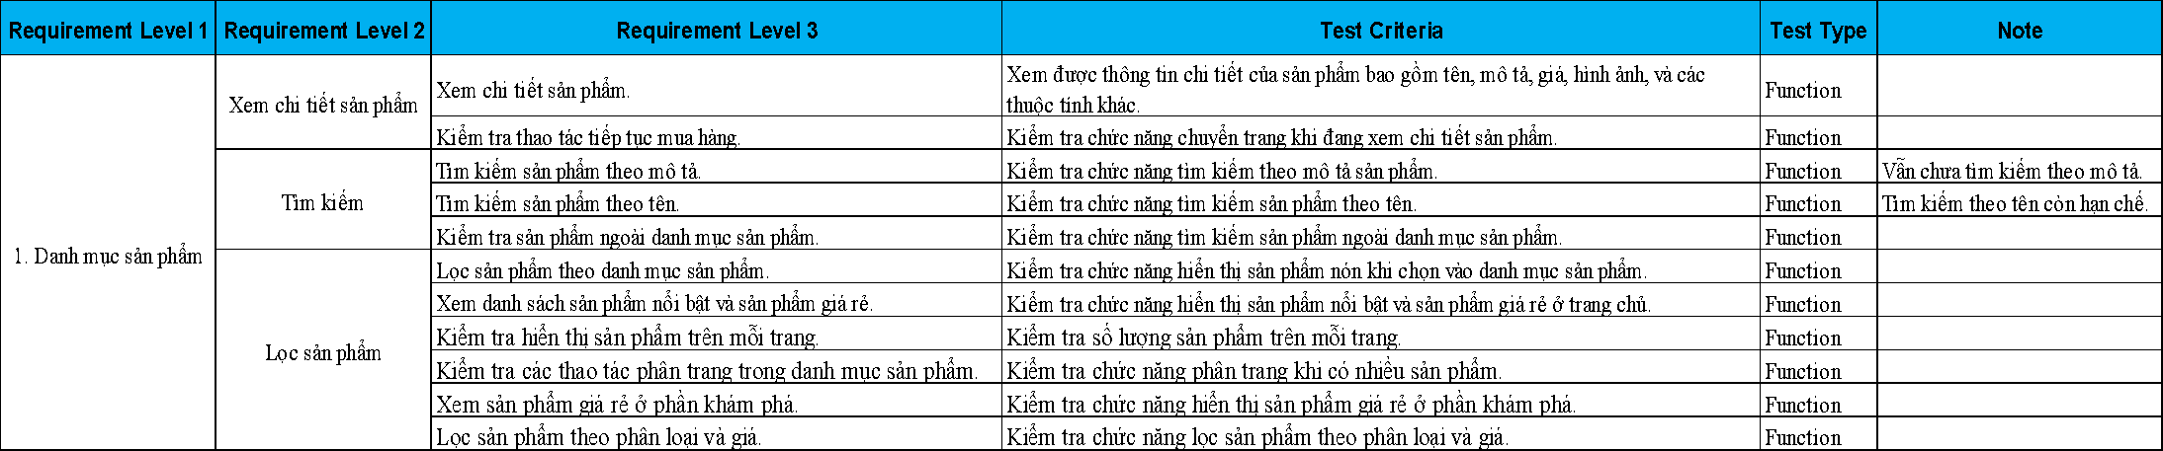

*Figure 4.3.1.1. Test Design of Product Catalog*

### Shopping cart

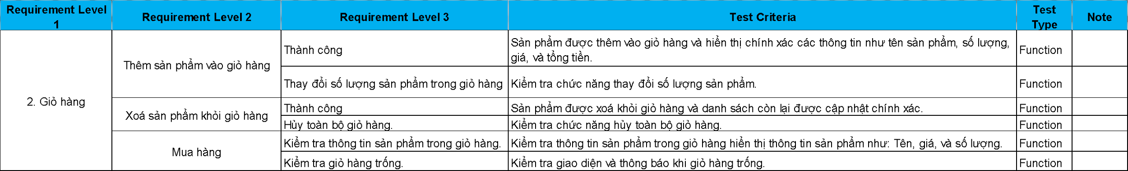

*Figure 4.3.2.1. Test Design of Shopping Cart*

### Payment processing

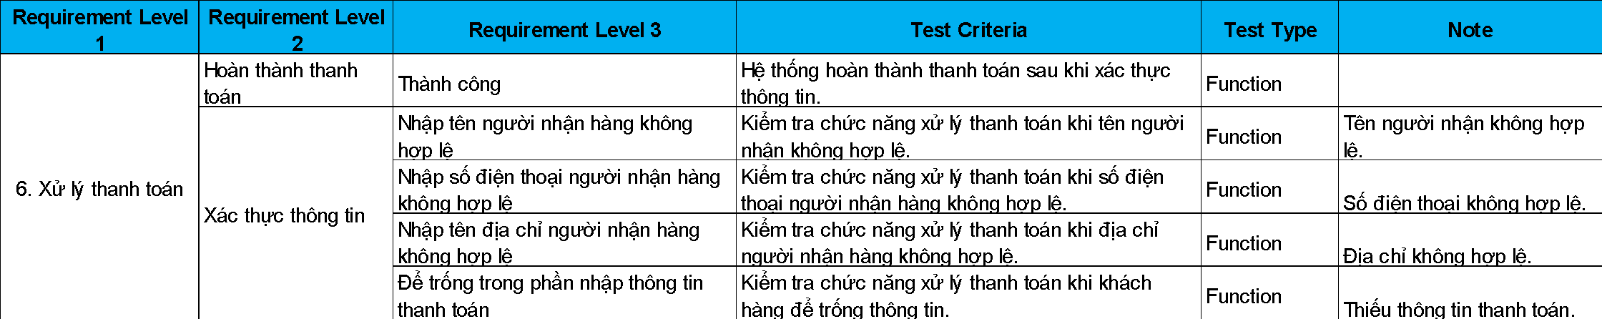

*Figure 4.3.3.1. Test Design of Payment Processing*

### Access control

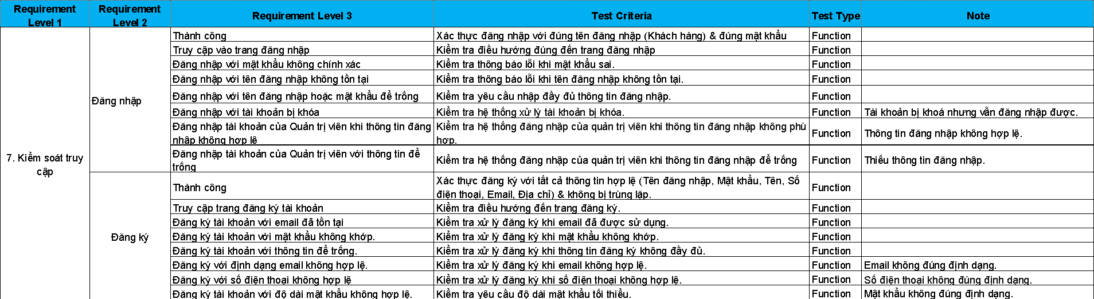

*Figure 4.3.4.1. Test Design of Access Control*

## Test Design Workflow

**Test Design Workflow** is a series of steps and activities performed to design test cases, test scenarios, and related elements to test a software or system. The goal of Test Design Workflow is to ensure that test cases are designed sufficiently to detect potential errors, satisfy functional and non-functional requirements, and ensure the quality of the product. **[3]**

Below is the workflow of 4 use cases: Product catalog, shopping cart, payment processing, access control.

### Product catalog

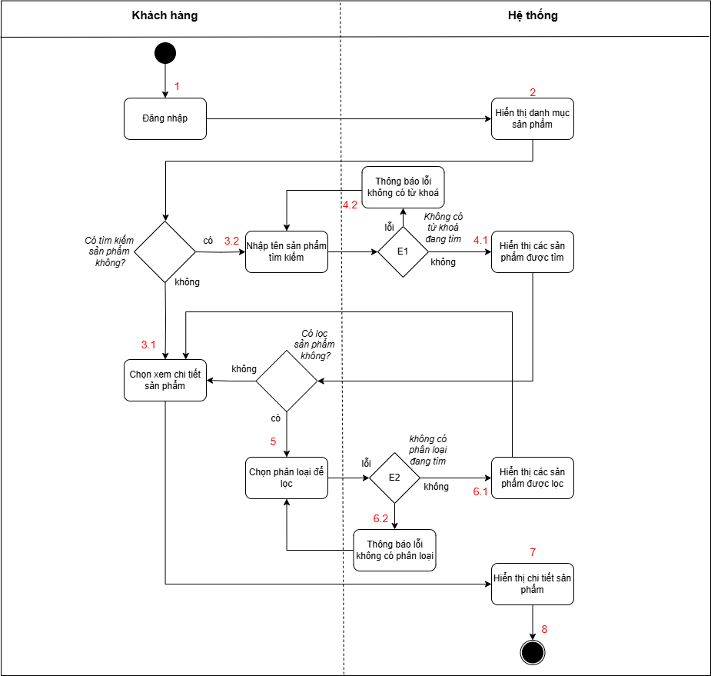

*Figure 4.4.1.1. Activity Diagram of Product Category*

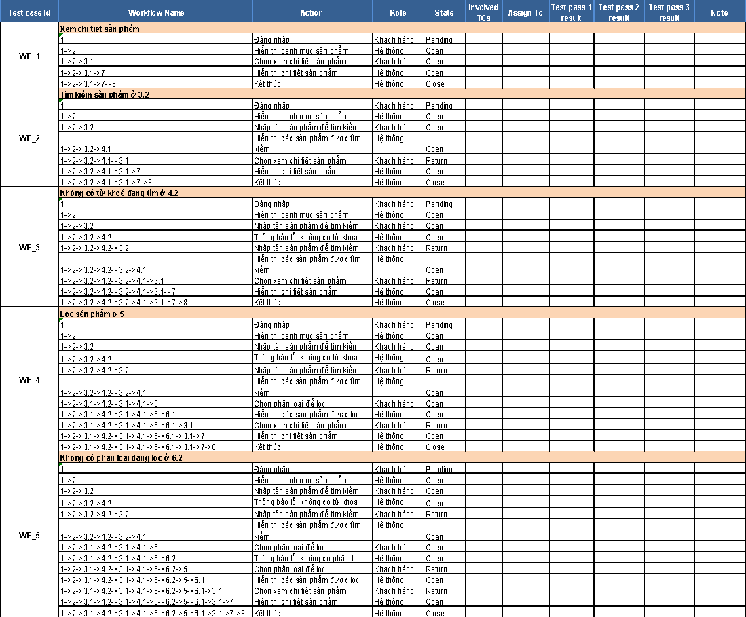

*Figure 4.4.1.2. Workflow of Product Catalog*

### Shopping cart

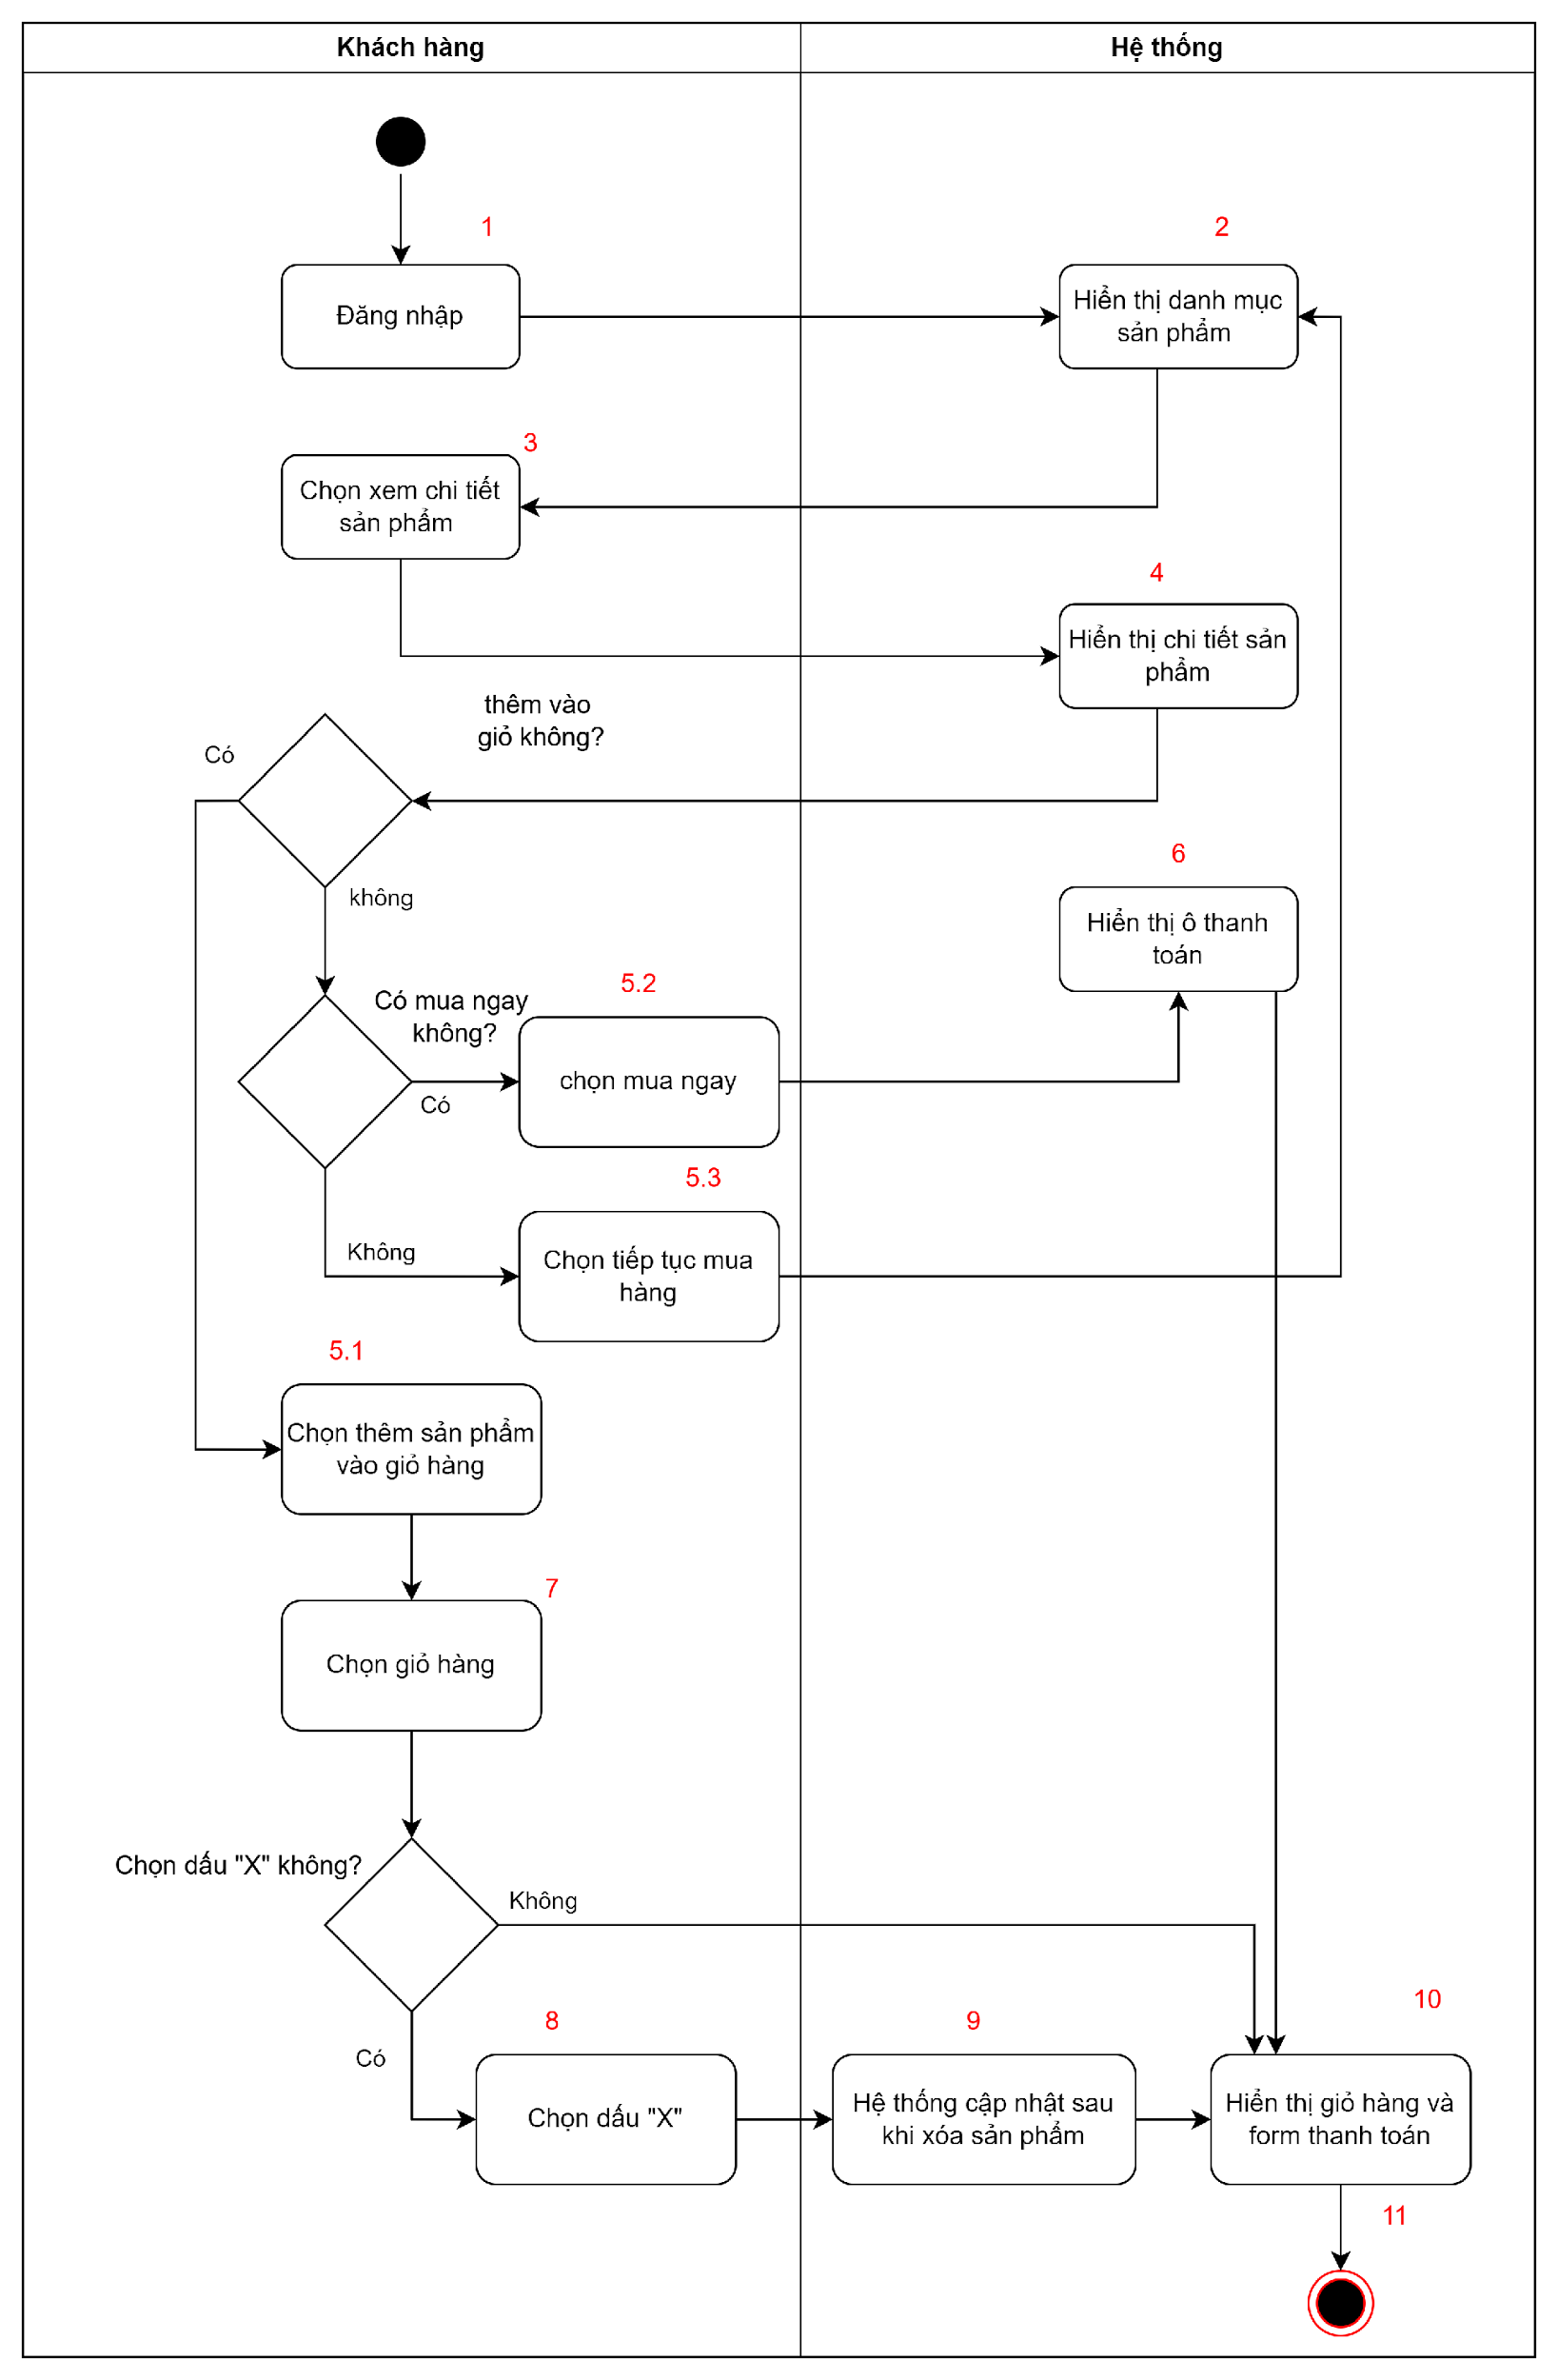

*Figure 4.4.2.1. Activity Diagram of Shopping Cart*

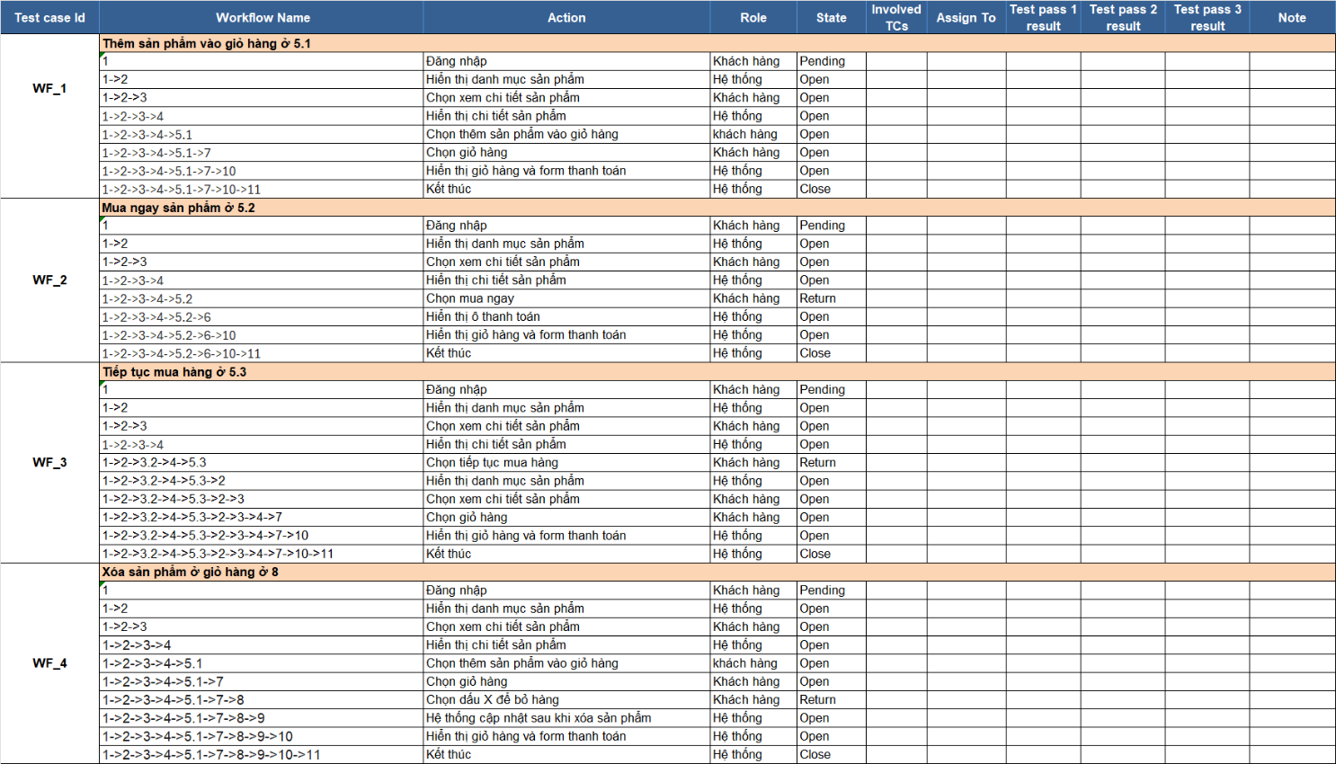

*Figure 4.4.2.2. Shopping Cart Workflow*

### Payment processing

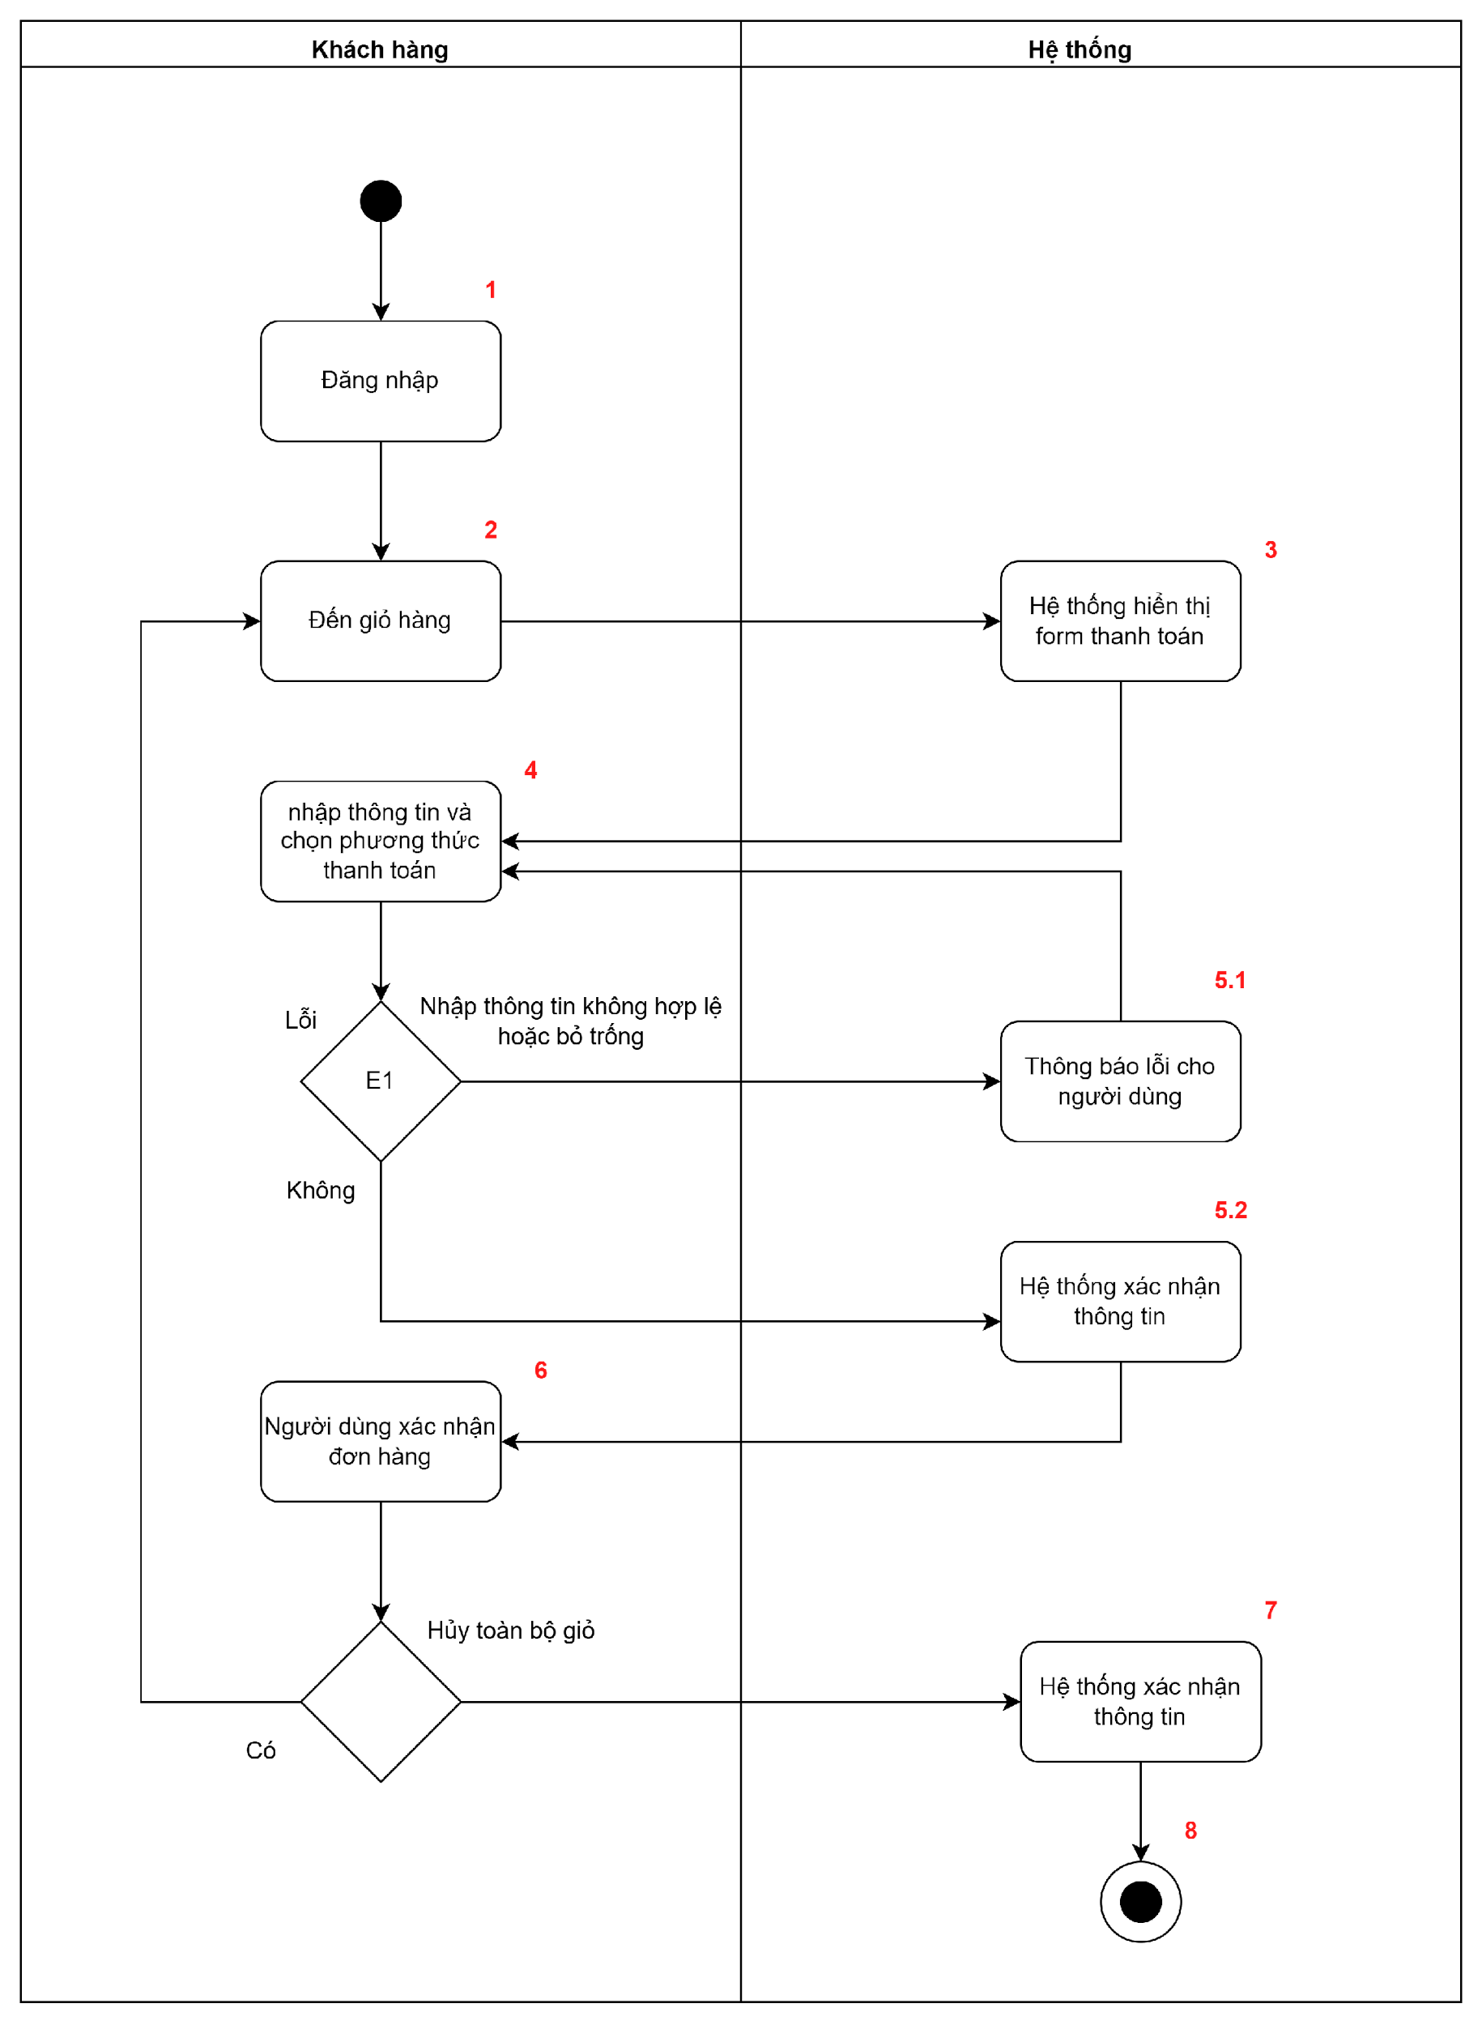

*Figure 4.4.3.1. Activity Diagram of Payment Processing*

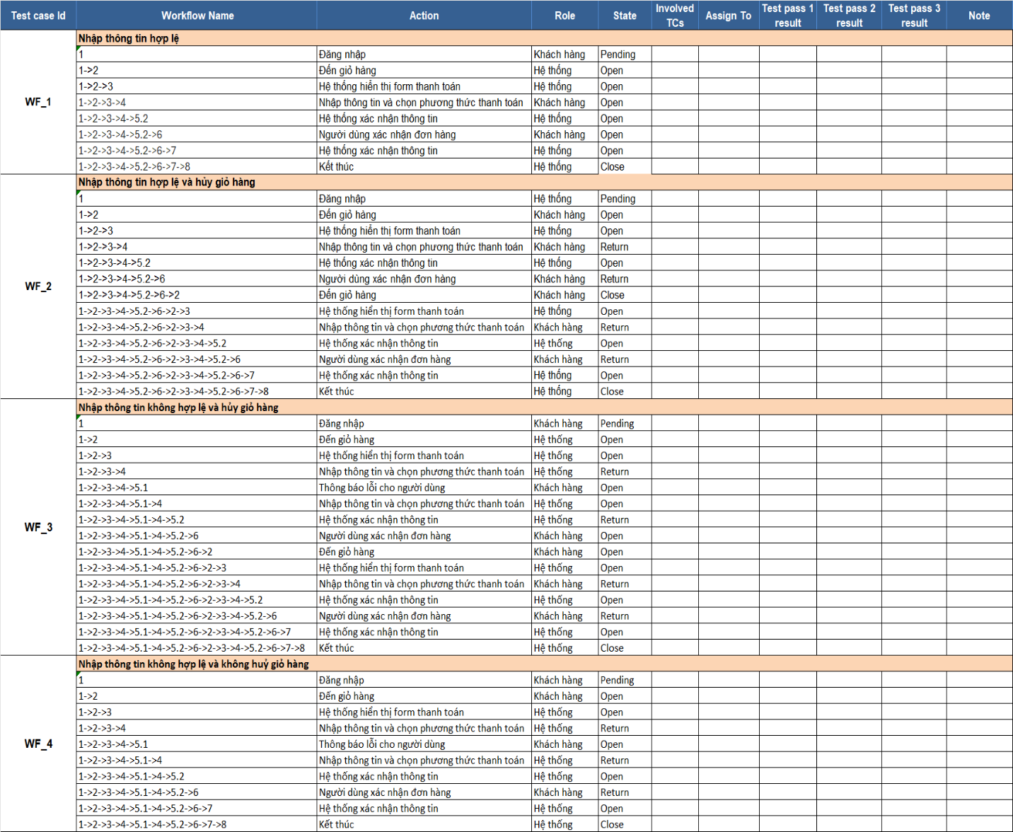

*Figure 4.4.3.2. Payment Processing Workflow*

### Access control

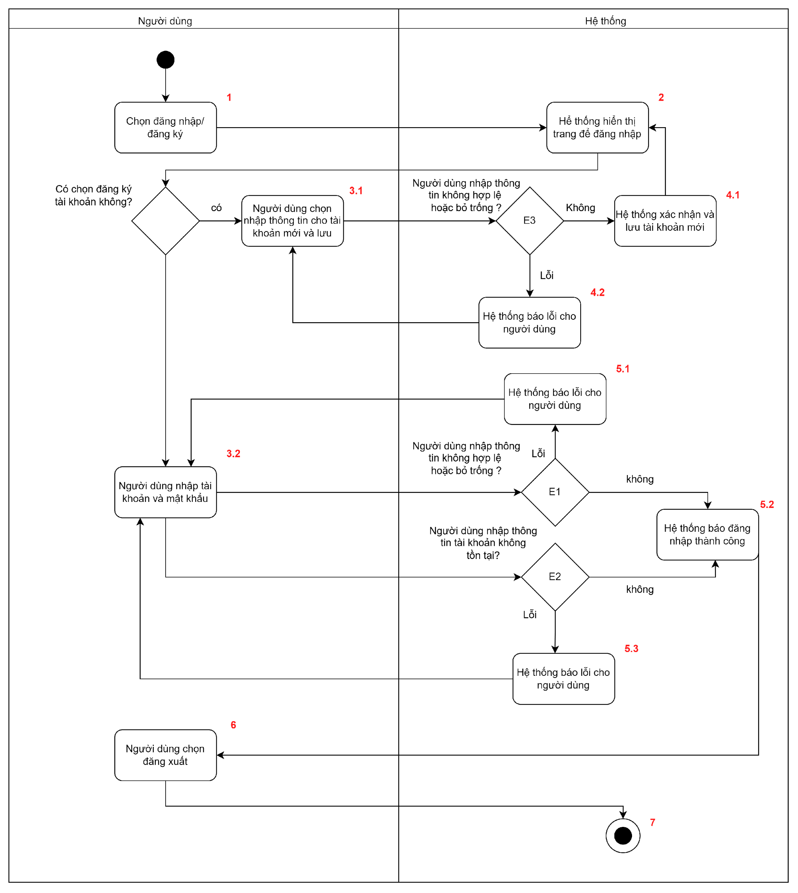

*Figure 4.4.4.1. Activity Diagram of Access Control*

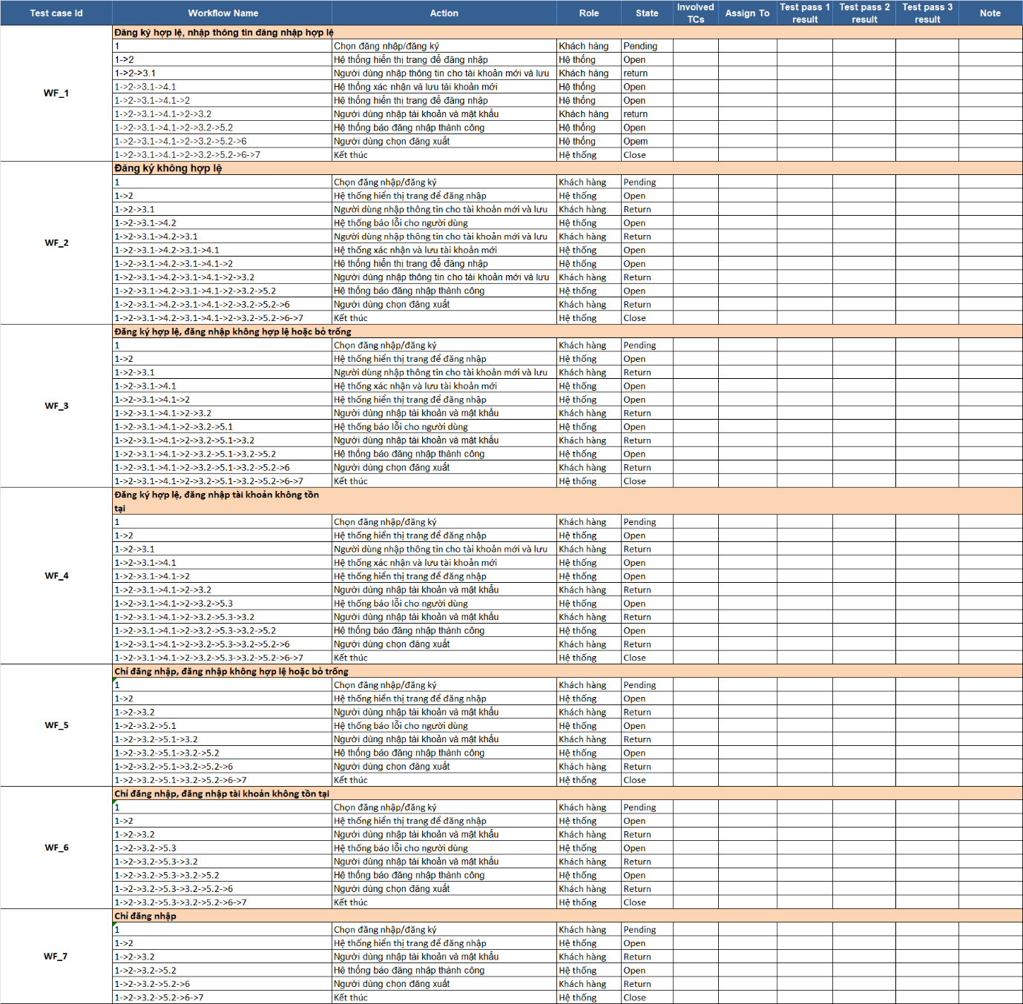

*Figure 4.4.4.2. Workflow of Access Control*

# TEST AND RESULTS

## Manual testing

### Bussiness Requirement Document (BRD)

*Bảng 5.1.1.1: Bussiness requirement document*

|  |  |  |  |
| --- | --- | --- | --- |
| BR# | Function name | Role | Describe |
| B1 | Login management | Customers, Administrators | - Customers can log in to the system to shop.  - Administrators can log in to manage products, orders, and user accounts. |
| B2 | Product management | Administrator | - Administrators can add, edit, delete and manage products.  - Admin can change price, image, product description. |
| B3 | Manage shopping cart | Client | - Customers can add products to the cart, edit quantities or delete products.  - The system must automatically calculate the total cart value when products are added or removed. |
| B4 | Payment management | Customers, Administrators | - Customers can choose a payment method and proceed with payment.  - Administrator confirms payment and updates order status. |
| B5 | Order management | Customers, Administrators | - Customers can track their order status (processing, delivered, canceled).  - Admin can update order status and process transactions. |
| B6 | Account management | Customers, Administrators | - Customers can update personal information (email, address, phone number).  - Administrators can edit and manage customer accounts. |
| B7 | Manage web interface | All users | - The website's interface must be easy to use and compatible with all devices (responsive).  - Interface elements must be clear and easy to manipulate. |
| B8 | Favorite management | Client | - Customers can save products to their favorites list for easy viewing later. |
| B9 | Manage product reviews | Client | - Customers can rate purchased products and leave comments for other customers. |
| B10 | Promotion management | Administrator, Customer | - Administrators can create promotions for products.  - Customers can use discount code when paying. |

### Technical Requirement Document (TRD)

*Bảng 5.1.2.1: Technical requirement document*

|  |  |  |
| --- | --- | --- |
| Function name | TR# | Detail |
| Login management | T1 | Username and password cannot be left blank. |
| T2 | Login name and password must be correct. |
| T3 | If the username and password are correct, login is successful. |
| T4 | Data entry fields must be active (login name, password). |
| Product management | T5 | Administrators can add, edit, and delete products from the product list. |
| T6 | Product name and description must be entered in full. |
| T7 | The new product code cannot be the same as an existing product. |
| T8 | Product price must be a positive number and greater than 0. |
| T9 | The input fields for products must function correctly. |
| Manage shopping cart | T10 | Customers can add products to the cart. |
| T11 | Customers can edit product quantities or delete products. |
| T12 | The shopping cart must display the correct products and total amount. |
| Order management | T13 | Customers can track order status (processing, delivered, canceled). |
| T14 | Admin can process orders and change order status. |
| T15 | Order information must be displayed correctly, including product, price, status. |
| Payment management | T16 | Customers can choose payment method (credit card, e-wallet, COD). |
| T17 | Payment buttons must be functional and error-free. |
| T18 | Successful payment will display a confirmation message. |
| Account management | T19 | Customers can update personal information (email, address, phone number). |
| T20 | Admins can edit or delete customer accounts. |
| T21 | Buttons and input boxes must function correctly. |
| Interface management | T22 | The website interface must be responsive and compatible with mobile and desktop devices. |
| T23 | The interface must be easy to use, and the buttons and forms must be easy to operate. |
| Manage favorite products | T24 | Customers can add or remove products to their favorites list. |
| Manage product reviews | T25 | Customers can rate and leave comments about the product. |
| T26 | The review buttons and input boxes must function correctly. |
| Customer management and account recovery | T27 | The system must support account recovery when customers forget their password. |

## Test case design

### Test cases according to the process

Below is a list of test cases according to 3 processes. Including:

* Process 1- Purchasing: Created by 4 use cases of access control, product catalog, shopping cart and payment processing.
* Process 2 - Product management: Created by 1 product management use case.
* Process 3 - Account management: Create by 1 use case a list of accounts.

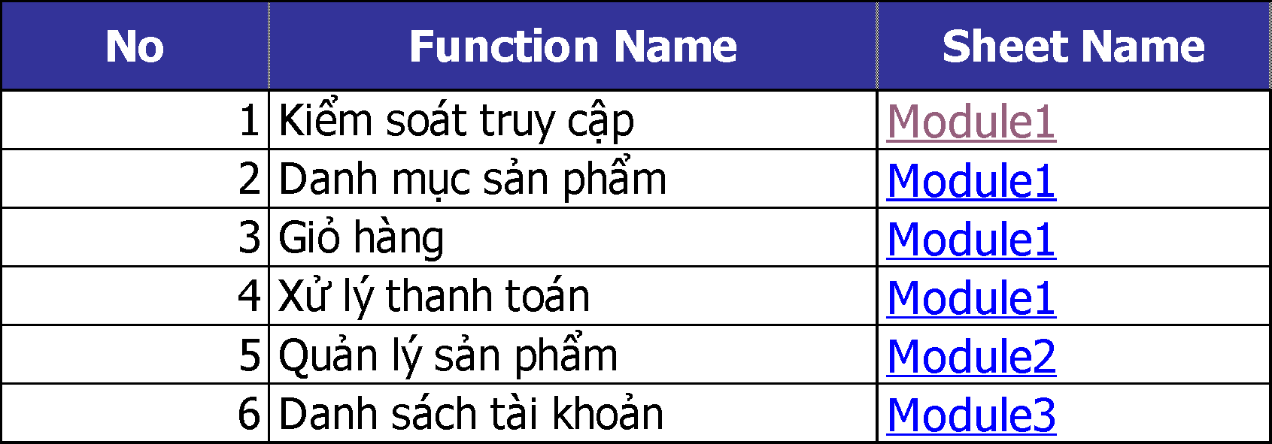

*Hình .. Danh sách test case theo quy trình*

#### Test cases of access control

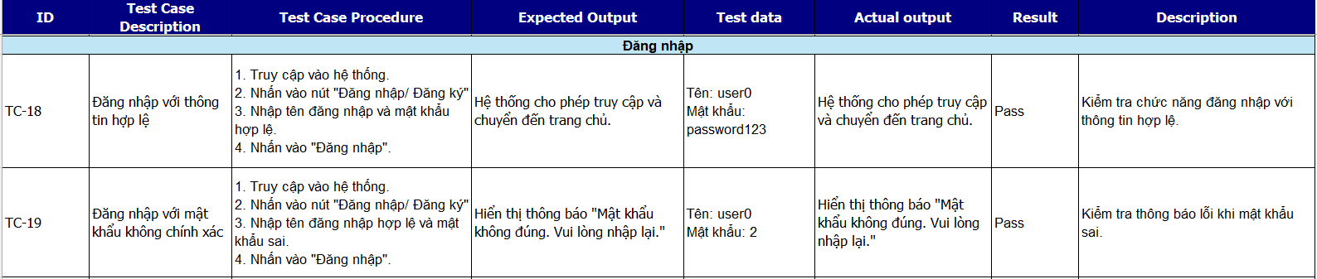

*Figure 5.2.1.2. Test case Login*

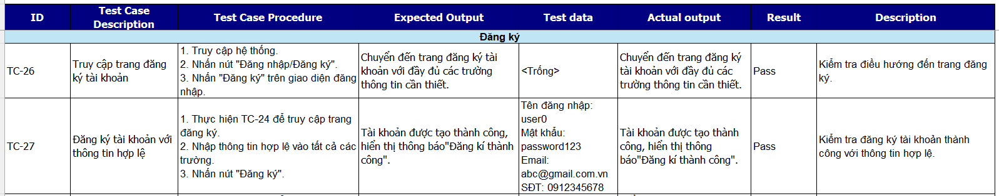

*Figure 5.2.1.3. Test case Register*

#### Test case product category

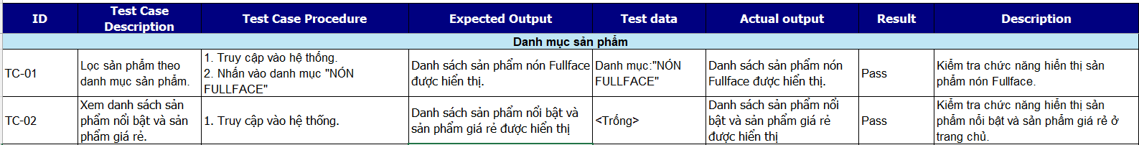

*Figure 5.2.1.4. Test case product category*

#### Test case shopping cart

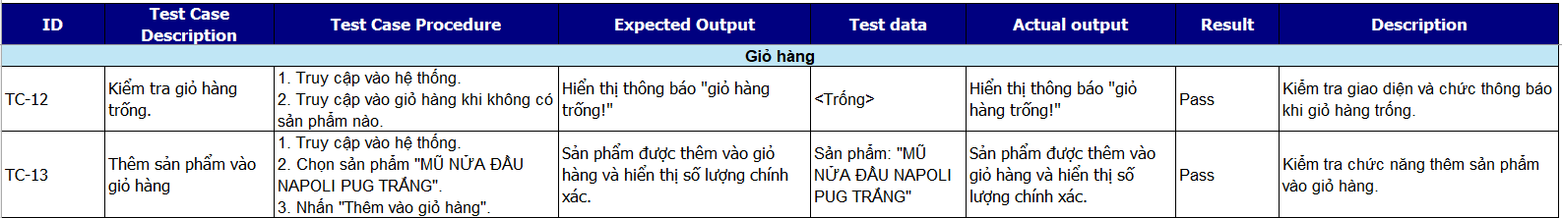

*Figure 5.2.1.5. Test case shopping cart*

#### Test case of payment processing

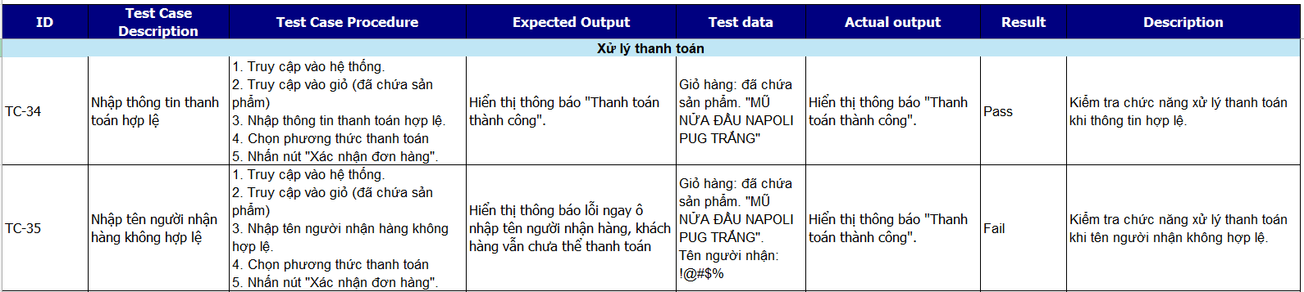

*Figure 5.2.1.6. Test case of payment processing*

### Test case cho unit test

Below is a list of unit test cases for 4 use cases: Access control, shopping cart, product catalog and account list.

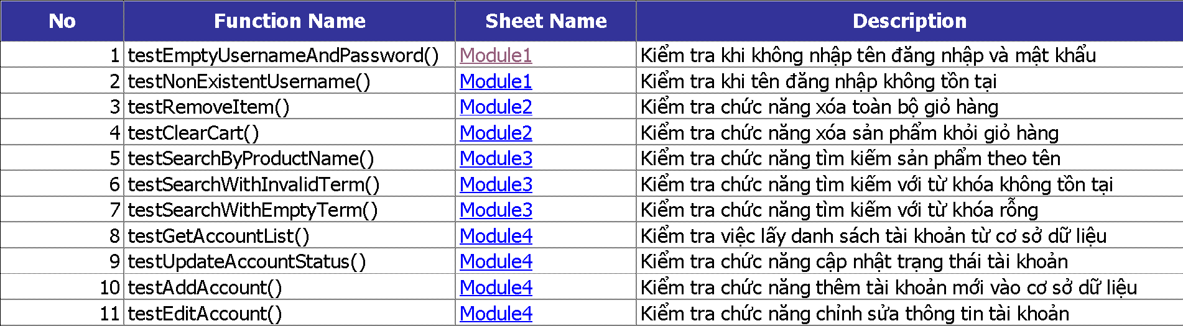

*Figure 5.2.2.1. List of test cases of unit test*

#### Unit test for Access Control use case

Below is the sequence diagram of the access control use case: **[4]**

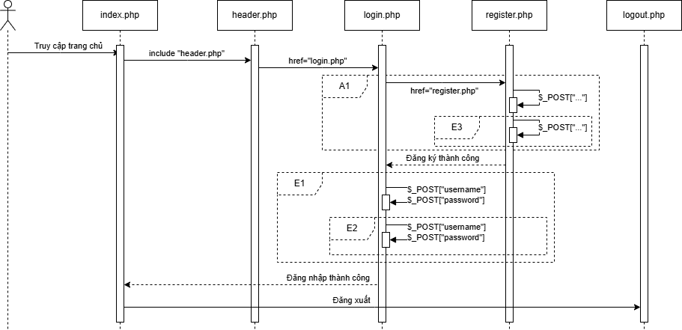

*Figure 5.2.2.2. Sequence diagram of Access Control*

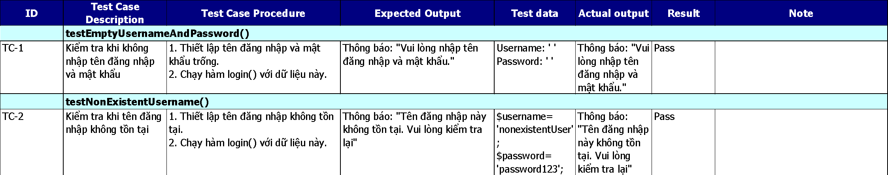

*Figure 5.2.2.3. Test case for unit test of Access Control*

#### Unit test for use case Product catalog

Below is the sequence diagram of the product category use case:

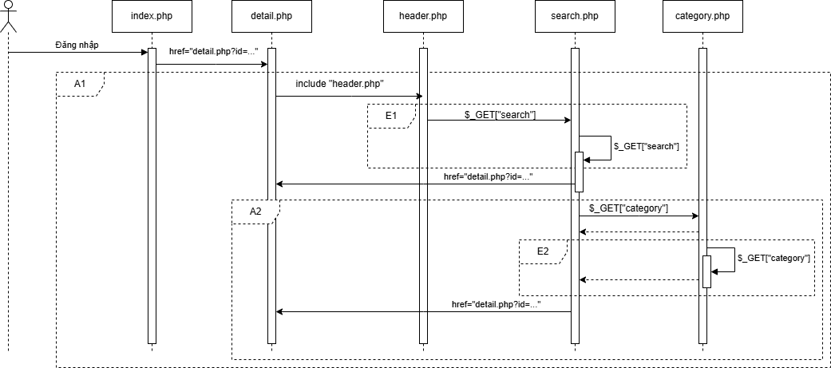

*Figure 5.2.2.4. Sequence diagram of Product Category*

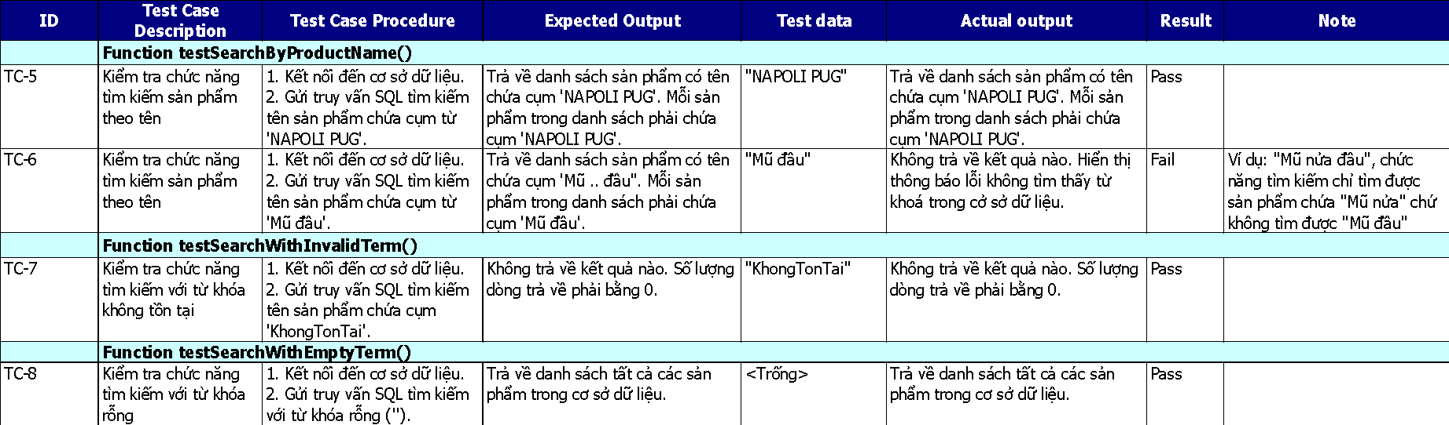

*Figure 5.2.2.5. Test case for unit test of Product Category*

#### Unit test for the Shopping Cart use case

Below is the sequence diagram of the shopping cart use case:

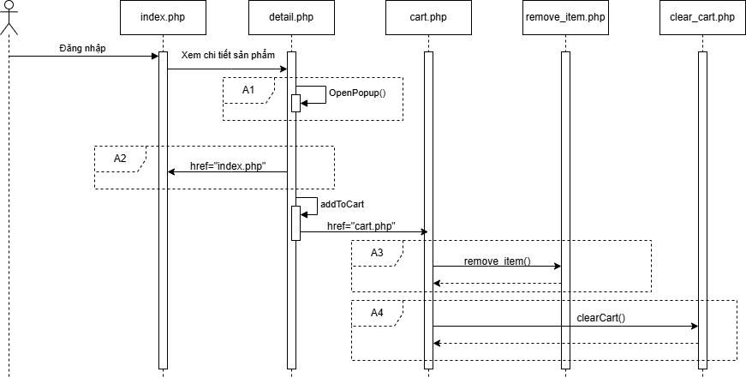

*Figure 5.2.2.6. Sequence diagram of the Shopping Cart*

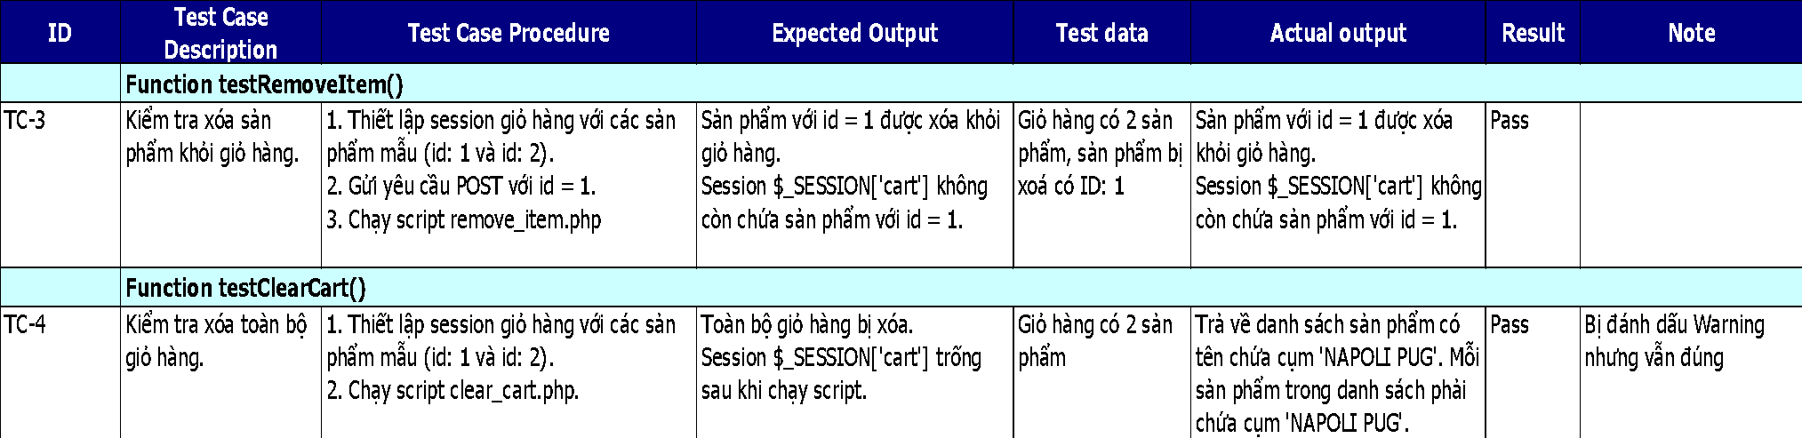

*Figure 5.2.2.7. Test case for unit test of Shopping Cart*

#### Unit test for use case List of accounts

Below is the sequence diagram of the account list:

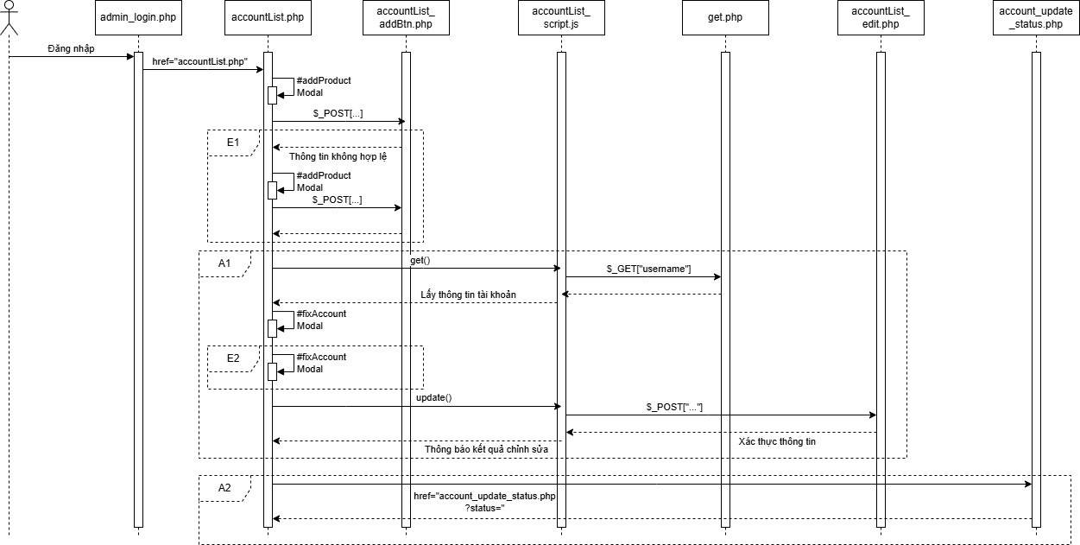

*Figure 5.2.2.8. Sequence diagram of Account List*

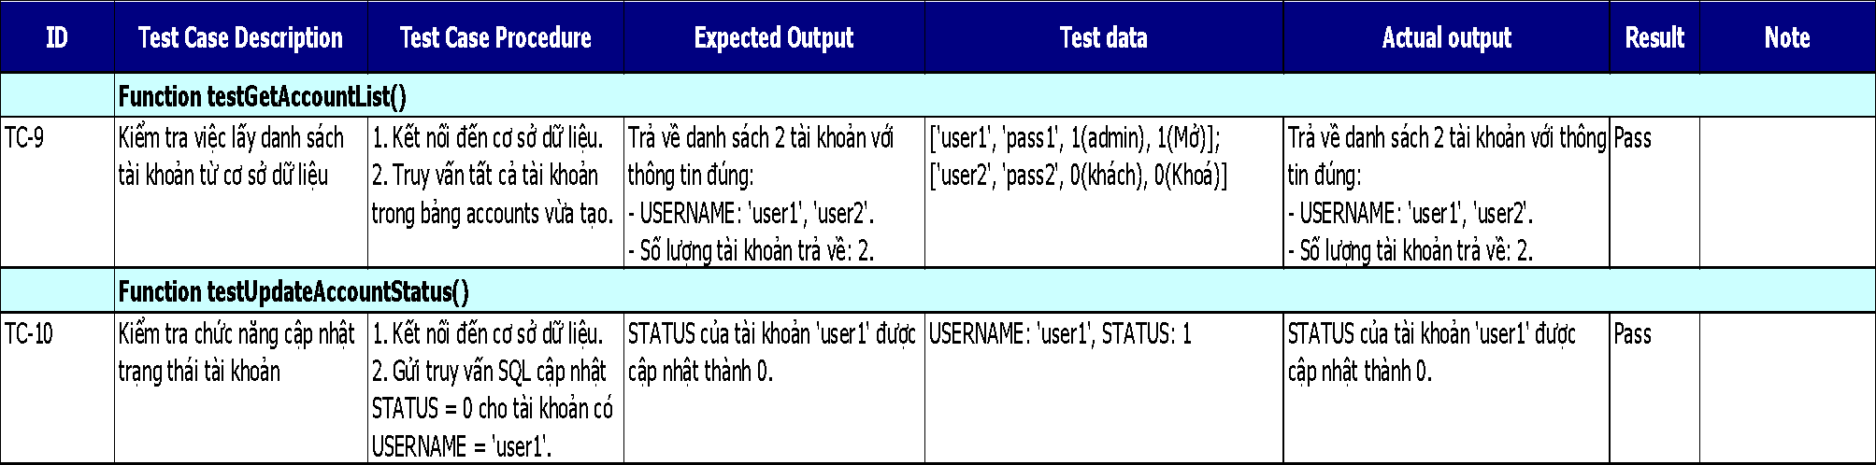

*Figure 5.2.2.9. Test case for unit test of Account List*

## Defect List

**Defect List**is a documented list of errors, defects, or problems discovered during a project or production. This list usually includes detailed information about the location, description of the error, attached images, start date and completion date of the error fix. [5]

In the construction field, Defect List is used to record defects during construction, ensuring project quality.

### Error in the Purchasing process

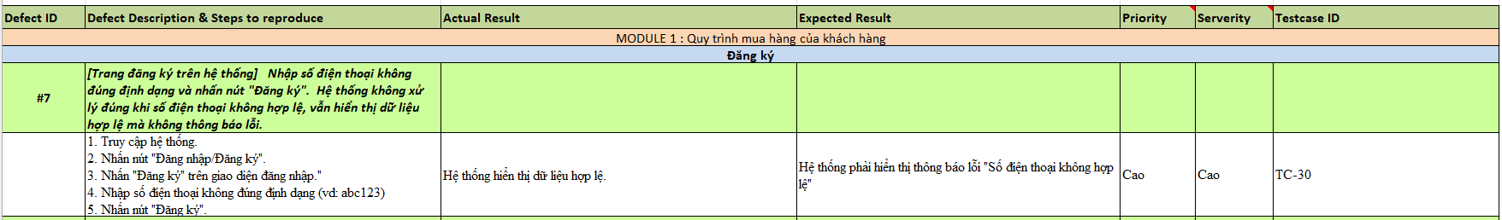

*Figure 5.3.1.1. An illustrative error of the purchasing process*

Below is an image demonstrating the above error:

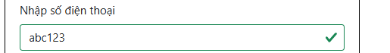

*Figure 5.3.1.2. Evidence of purchasing process errors*

### Error in the Product Management process

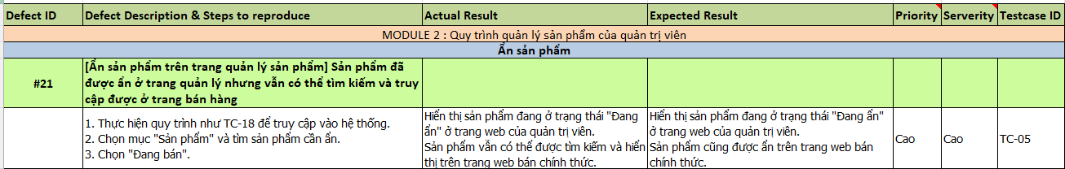

*Figure 5.3.2.1. An illustrative failure of the Product Management process*

Below is an image demonstrating the above error:

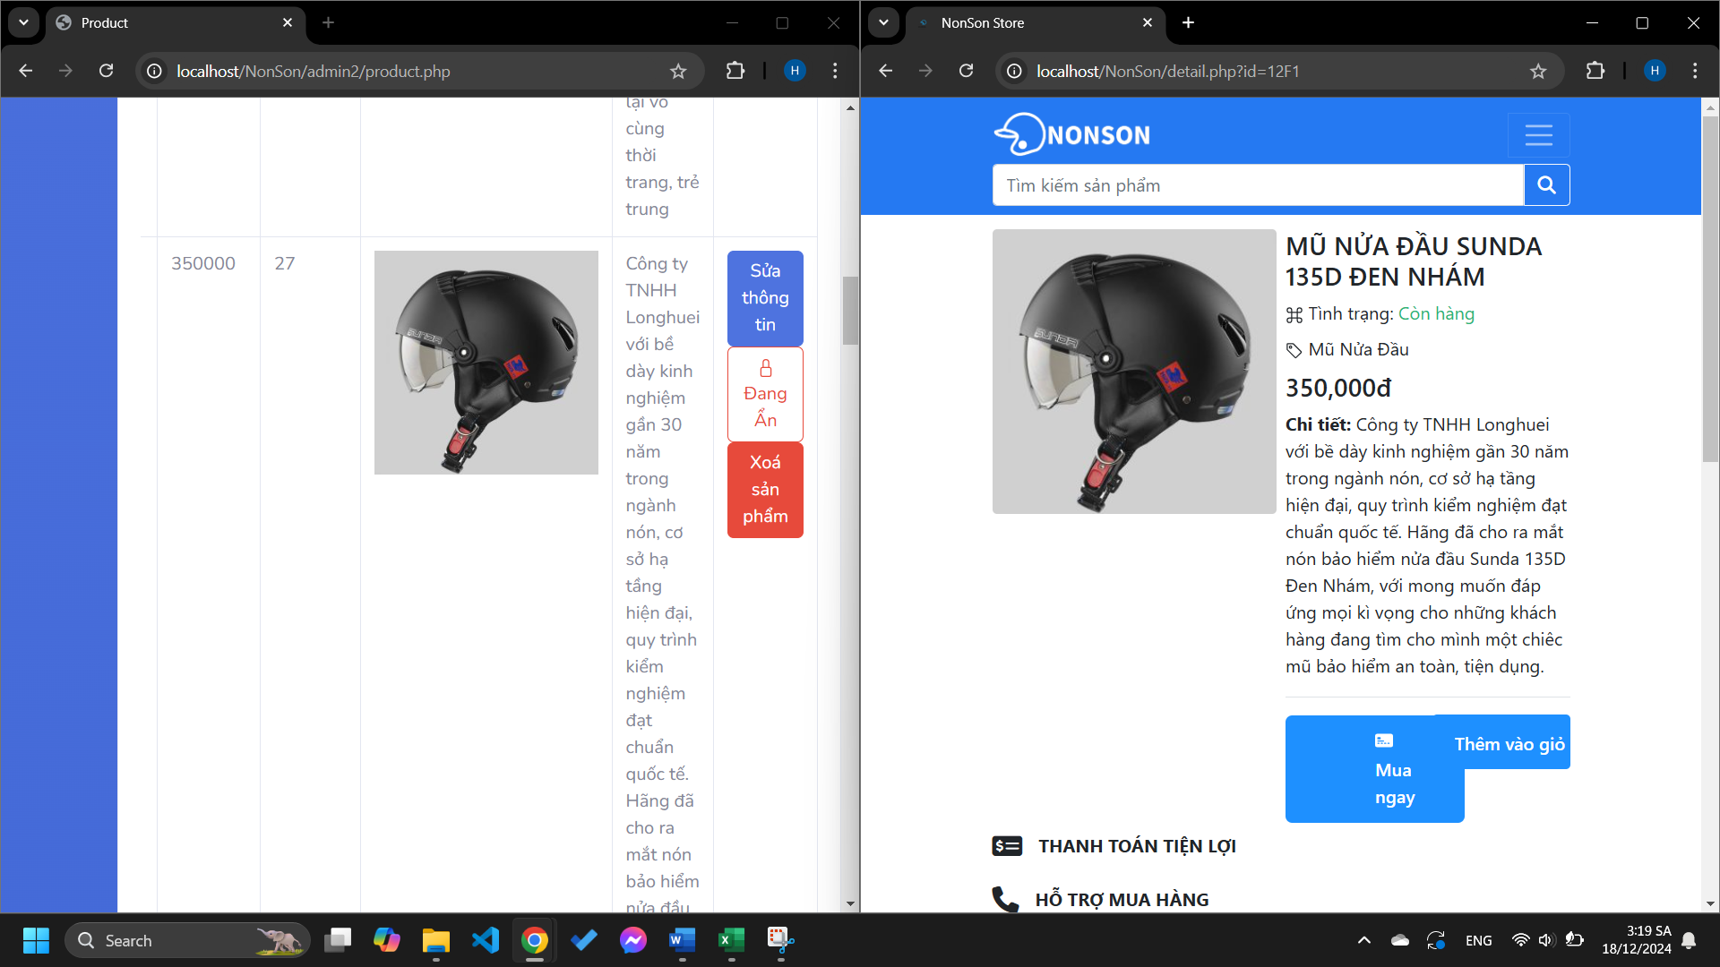

*Figure 5.3.2.2. Evidence of Product Management process errors*

### Error in Account Management process

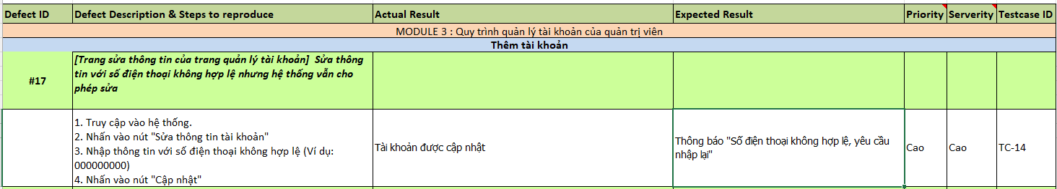

*Figure 5.3.3.1. An illustration of an Account Management process error*

Below are images demonstrating the above error:

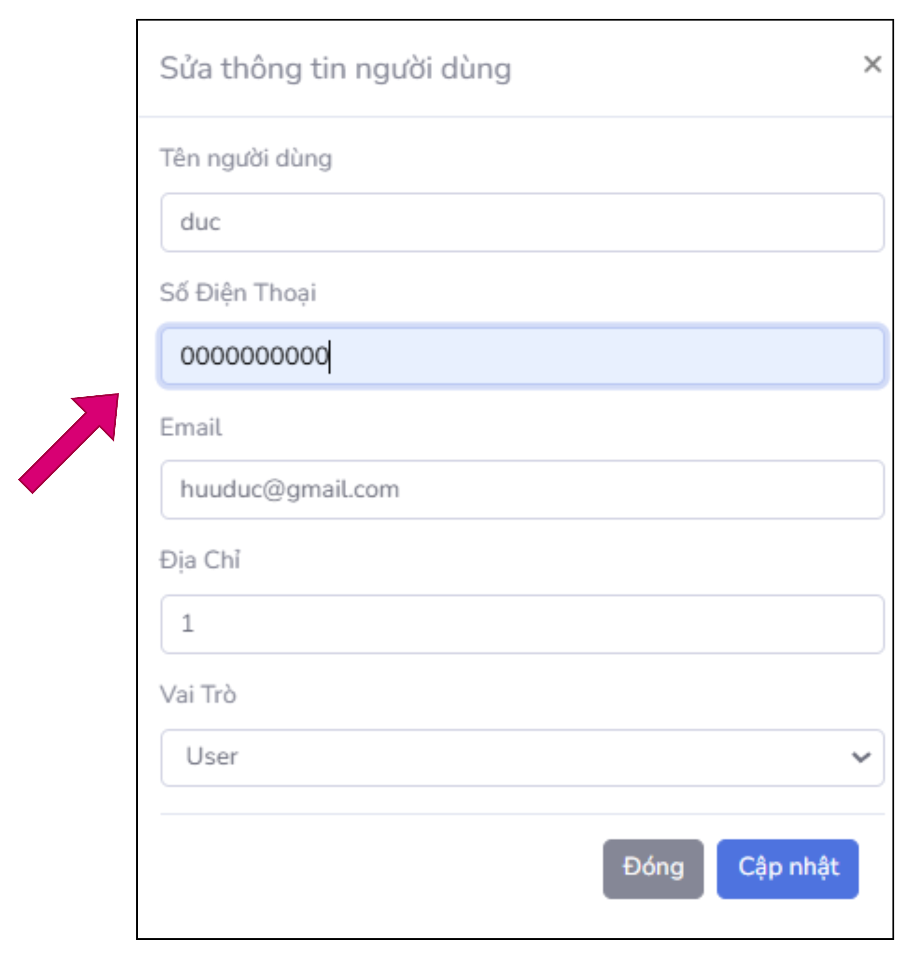

*Figure 5.3.3.2. Evidence of errors in the Account Management process*



*Figure 5.3.3.3. Evidence of errors in the Account Management process (2)*

## Test Results (Test Report)

**Test Report** is a report that records all information related to testing objectives, testing activities performed, test results, and problems discovered during testing.

It is an important tool for evaluating software quality, helping stakeholders such as programmers, testers, and management better understand the product's status.

### Test results according to the process

Based on *Figure 5.2.1.1* List of test cases of 3 processes: Purchasing process, product management process and account management process. We get the following test results:

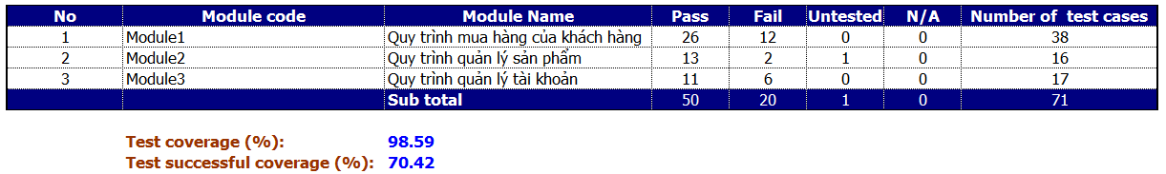

*Figure 5.4.1.1. Test report of 3 processes*

The report shows the test results of three software modules, including a total of 71 test cases. The test coverage rate reached 98.59%, proving that almost all test cases have been executed, except for 1 case that is still "Untested". However, the success rate of the test cases was only 70.42%, indicating that there were 20 failure cases that needed to be fixed. In there, **Module1** - The customer purchasing process has the largest number of test cases (38) but also recorded 12 failed cases. **Module3** and **Module2** There are fewer errors, but Module2 still has 1 untested case. In summary, the testing results show that the software still needs to be reviewed more thoroughly, focusing on errors to improve overall quality.

### Test results according to unit test

Based on *Figure 5.2.2.1*, the test case list of unit tests includes 11 functional functions from 4 use cases: Access control, product catalog, shopping cart and account list. We get the following test results:

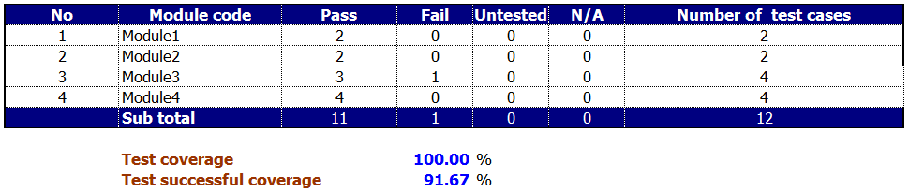

*Figure 5.4.2.1. Test reports of unit tests*

The report shows the test results of 4 software modules with a total of 12 test cases. The test coverage rate reached 100%, proving that all test cases were fully executed. However, the success rate only reached 91.67%, with 11 test cases achieving Pass results and 1 test case failing. Specifically, **Module1** and **Module2** Both have 2 test cases, and both modules have completely successful results with 0 errors. Meanwhile, **Module3** There were 4 test cases, recording 3 Pass and 1 Fail, showing that this module needs to be reviewed and existing errors fixed. **Module4** With 4 test cases, perfect results were achieved with 4 Passes and no errors occurred. Overall, the test results show that the majority of modules operate stably, except for Module3, where an error was detected that needs to be fixed to ensure the overall quality of the software.

## Bug Report

**Bug report** A detailed document or form used to report specific errors to the development team.

**Purpose**: Provides detailed information to help programmers understand and reproduce errors for correction.

### Bug number 1

**Bug ID**: #1  
**Title**: The system allows login with invalid information on the Administrator screen.

**Error description**:  
When the user enters **login name** and **Any password is invalid** then press "Login", system **allowed access successfully** and go to the Admin home page instead of showing an error message.

**Severity**: Serious  
**Priority**: Urgent  
**Test case ID**: TC-24

**Steps to reproduce the error:**

1. Access the Administrator system login screen.
2. Enter any invalid username and password.
3. Click the "Login" button.

**Actual results:**

The system allows access and redirects to the Administrator home page.

**Expected results:**

The system must display the error message: **"Invalid login information"** and do not allow users to log in to the Administrator system.

**Evidence:** The proof image is in the file “5_Defect_List_Template.xls” at Test Evidence #4.

### Second bug

**Bug ID**: #2  
**Title**: The system allows login when leaving information blank on the Administrator screen.

**Error description**:  
When users **Leave the username and password blank** then press "Login", the system remains **allowed access successfully** and go to the Admin home page instead of showing an error message.

**Severity**: Serious  
**Priority**: Urgent  
**Test case ID**: TC-25

**Steps to reproduce the error:**

1. Access the Administrator system login screen.
2. Leave the username and password blank.
3. Click the "Login" button.

**Actual results:**

The system allows access and redirects to the Administrator home page.

**Expected results:**

The system must display the error message: **"Login information is blank"** and do not allow users to log in to the Administrator system.

**Evidence:** The proof image is in the file “5_Defect_List_Template.xls” at Test Evidence #5.

# CONCLUDE

## Conclude

In today's era, the Internet has been developing at breakneck speed, creating the foundation for the birth of a series of Web applications that meet the diverse needs of people in all areas of life. This strong development not only brings opportunities but also poses great challenges in product quality, as users have increasingly higher expectations for experiences on Web applications. They require applications that are not only user-friendly, fast, and convenient, but also must operate stably and without errors throughout use.

With the topic "Testing Non Son Website," the content of the report presented in detail about software testing and applying testing techniques to a specific Web application. We have analyzed, designed and built a functional test suite to ensure the system operates as required and brings the best user experience.

## Development direction

Although the report has successfully built an automated testing program, the current tool still focuses on certain functions and does not fully test the Web application. In the future, development will focus on performance optimization, expanding the scope of testing to include performance, interface, and security testing. At the same time, integrating modern tools such as Selenium WebDriver and JMeter, to build a comprehensive testing system, ensuring application quality in all aspects.

# REFERENCES

|  |  |
| --- | --- |
| [1] | D. N. Tai, KTPM - Chapter 1 - Overview of Testing. |
| [2] | D. N. Tai, KTPM - Chapter 2 - Testing Process and Planning. |
| [3] | D. N. Tai, KTPM - Chapter 3 - White-Box Testing. |
| [4] | D. N. Tai, KTPM - Chapter 4 - Black-Box Testing. |
| [5] | D. N. Tai, KTPM - Chapter 5 - Program Verification. |